Missouri Statute Section 226.180 was repealed in 1979 and replaced with Statutes 558.011, 560.011, 576.010 and 576.020.
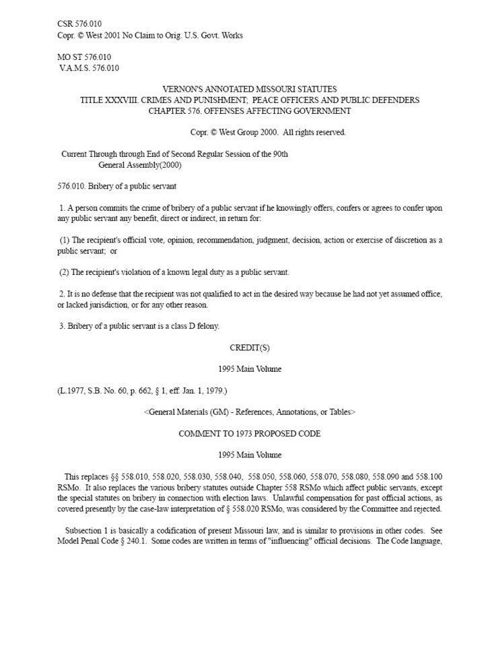
Page 1 of Missouri Statute Section 576.010: Bribery of a public servant, which replaced Missouri law 226.180.
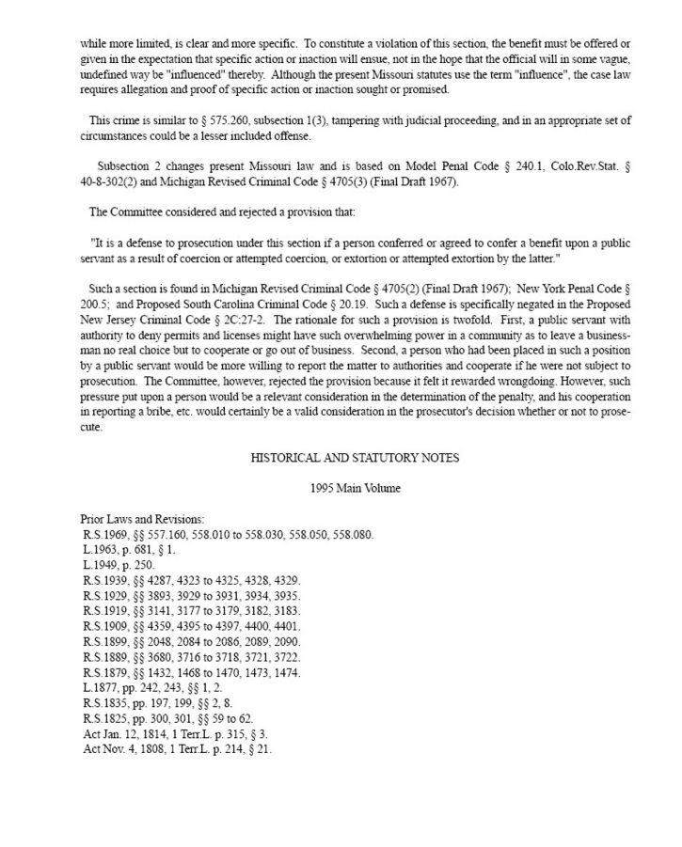
Page 2 of Missouri Statute Section 576.010: Bribery of a public servant, which replaced Missouri law 226.180.
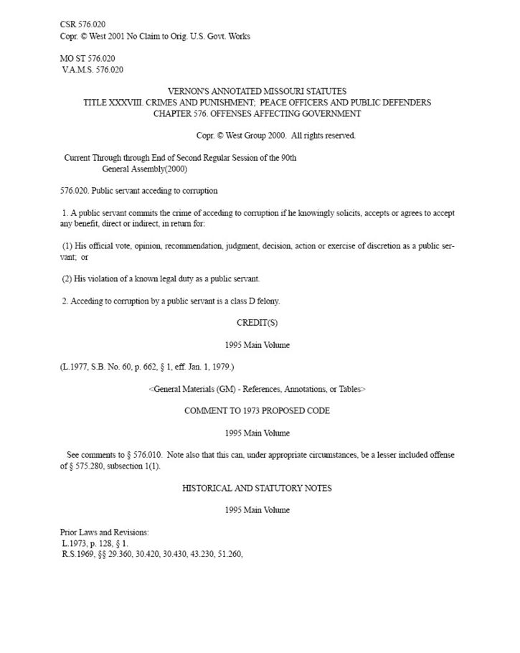
Page 1 of Missouri Statute Section 576.020: Public servant acceding to corruption, which replaced Missouri law 226.180.
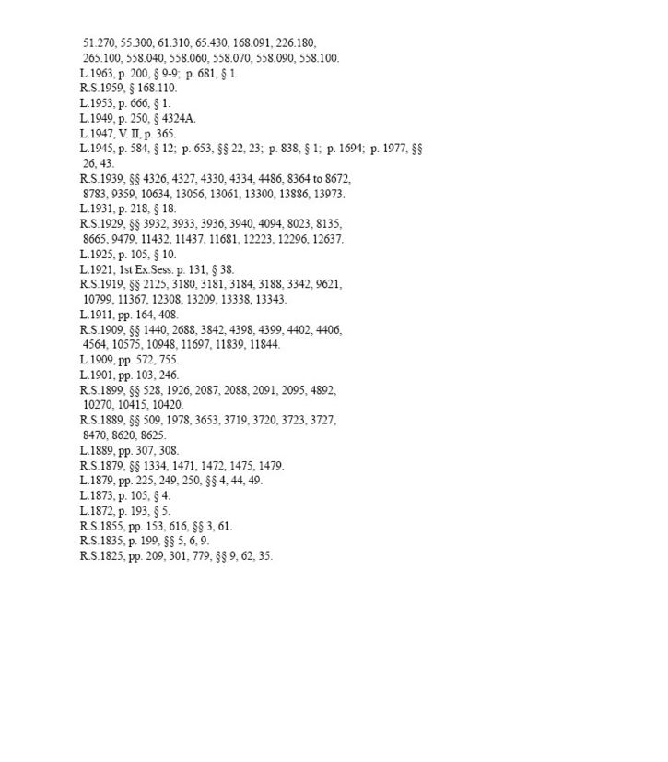
Page 2 of Missouri Statute Section 576.020: Public servant acceding to corruption, which replaced Missouri law 226.180.
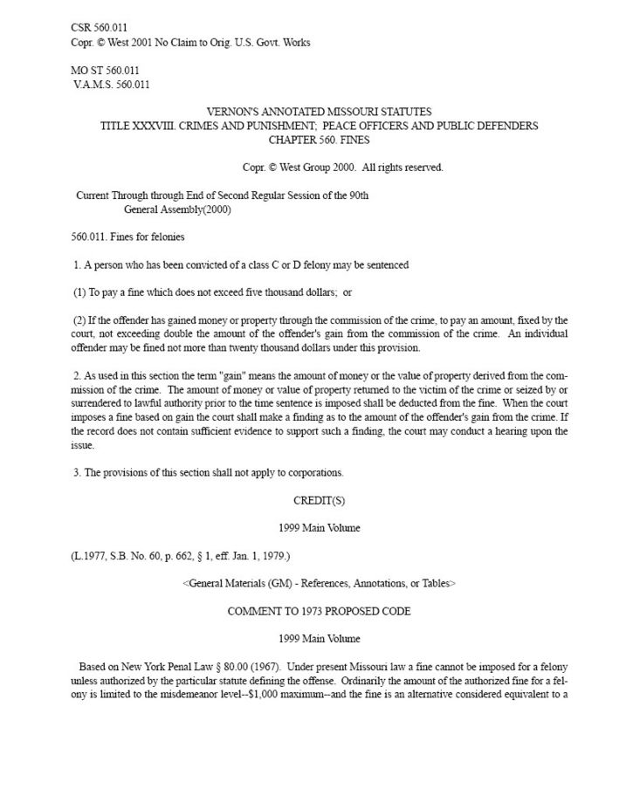
Page 1 of Missouri Statute Section 560.011: Fines for felonies.
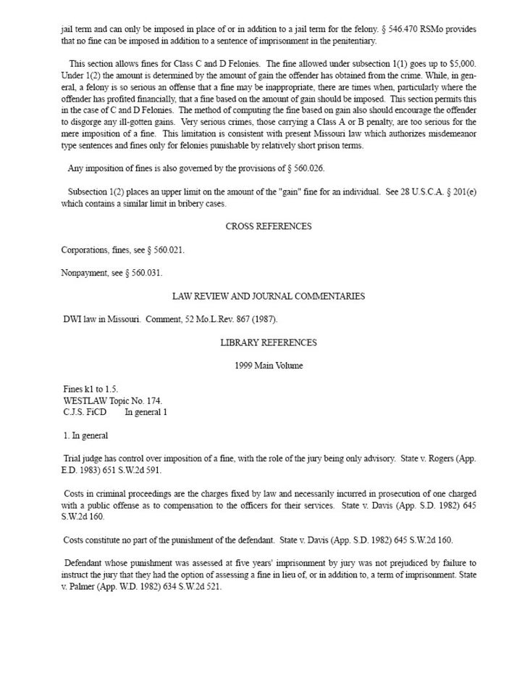
Page 2 of Missouri Statute Section 560.011: Fines for felonies.
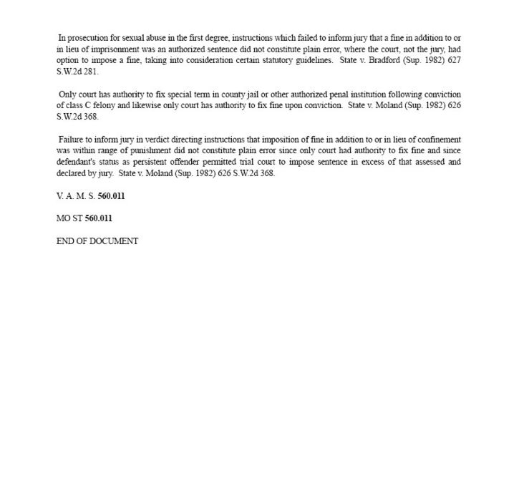
Page 3 of Missouri Statute Section 560.011: Fines for felonies.
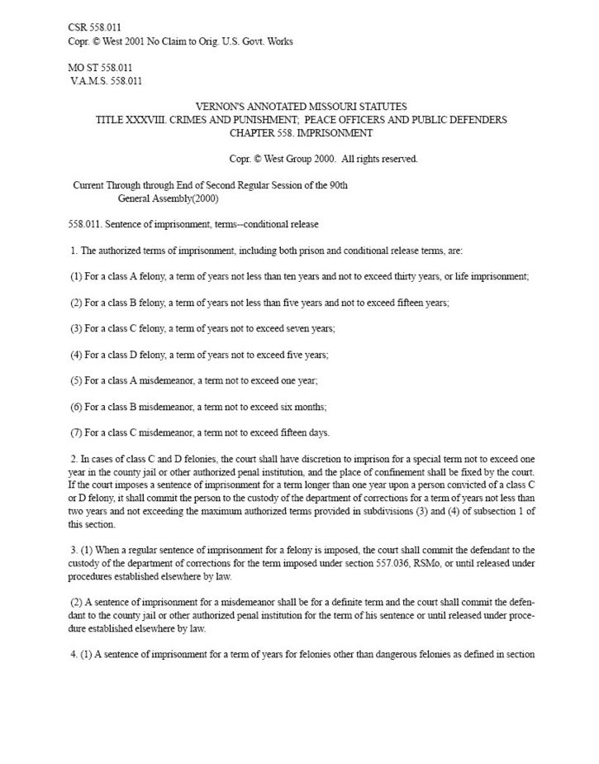
Page 1 of Missouri Statute Section 558.011: Sentence of imprisonment.
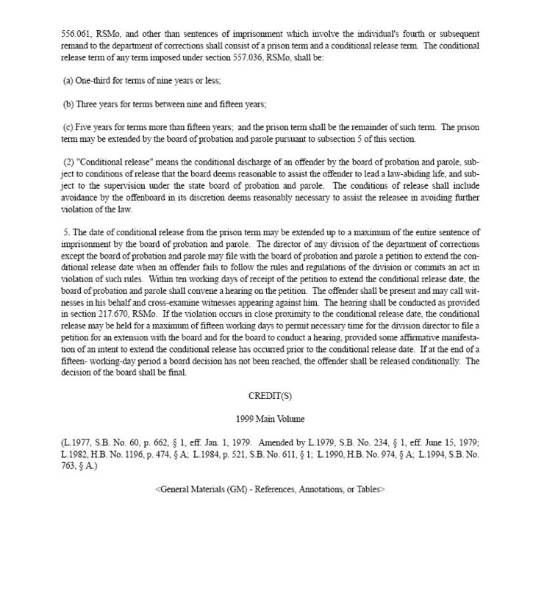
Page 2 of Missouri Statute Section 558.011: Sentence of imprisonment.

