Quick Reference Guide: Change Orders - Zero Dollar
This article is intended to guide the user in the creation of a zero dollar change order. The example given is to add Job Special Provisions. The same would apply for Specification changes or reducing the contract DBE goal.
- Complete the change order Header for the contract. Select "Combination" for the Reason Code and "Zero Dollar" for the Function. Select "Division Approval" for CO Type. User may have to Override Approval Rules.
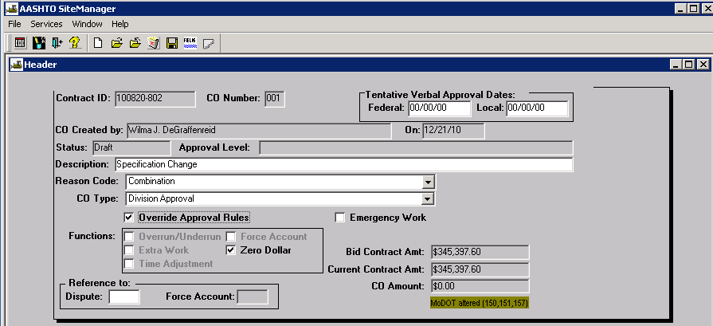
- Do not add any change order items.
- Navigate to Change Order Explanations and select "General Change Order Explanations" from the drop down list. Click the New icon and enter the explanation, including the effected line number(s) in the reason, if necessary.
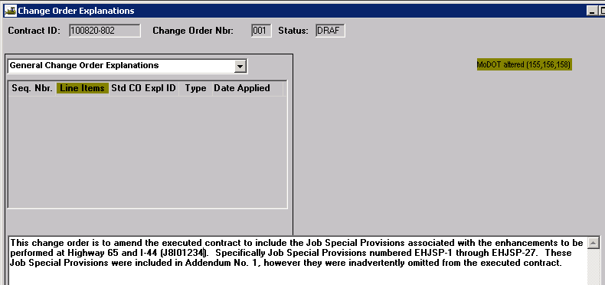
- Once the Header information is changed from Draft to Pending, print the Official MoDOT ZERO DOLLAR Change Order Report from Cognos 8 and save as directed by MoDOT policy.

