Traffic Segment Hourly Volume Directions

1. Enter the Transportation Management Systems intranet page.
2. Click on the triangle titled “Client Server Applications”.
3. Click on “Client Manager”.
4. Click on the tab titled “Open”.

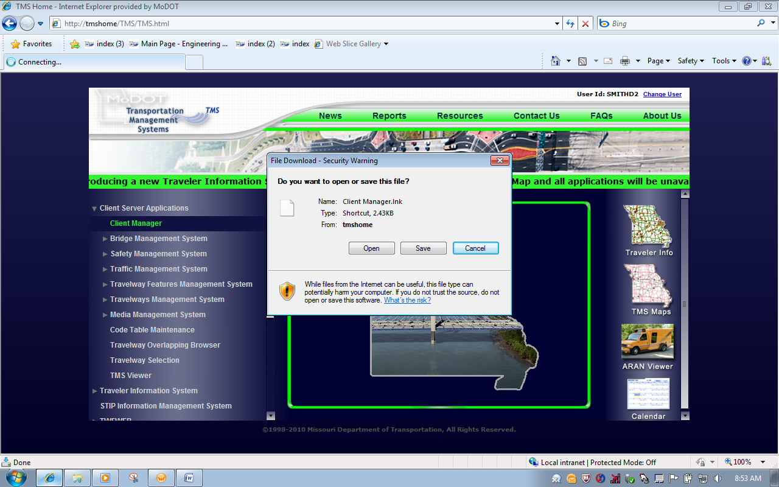

5. Fill in the Userid and Password. The password is the same as the Userid.

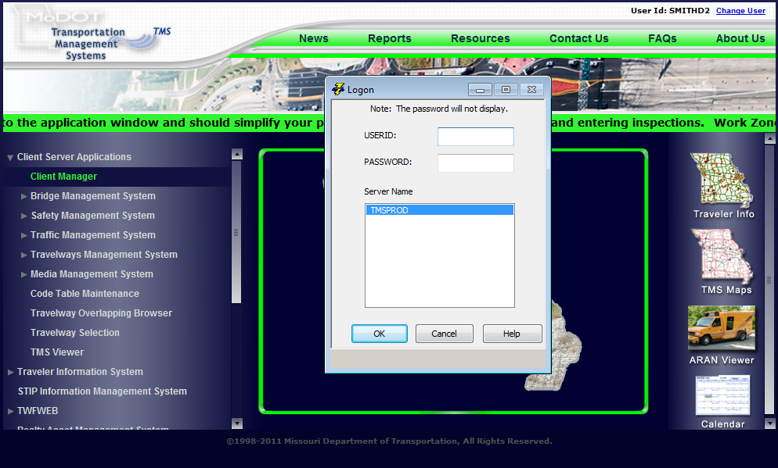

6. Click on the triangle titled “Traffic Management Systems.
7. Click on “Traffic Segment Hourly Volume.
8. Click on the tab titled “Open”.

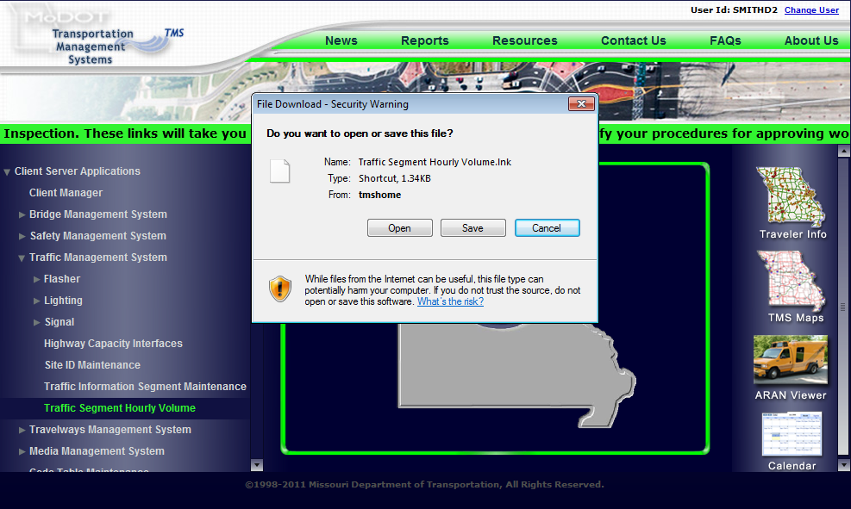

9. Fill in the Designation, IS, US, MO, RT, etc.
10. Fill in Travelway Name – 70, 136, A DD, etc.
11. Fill in Direction North, South, East, or West.
12. Select “Display Counties in”.
13. Select an appropriate county.
14. Click on “Travelways” button.

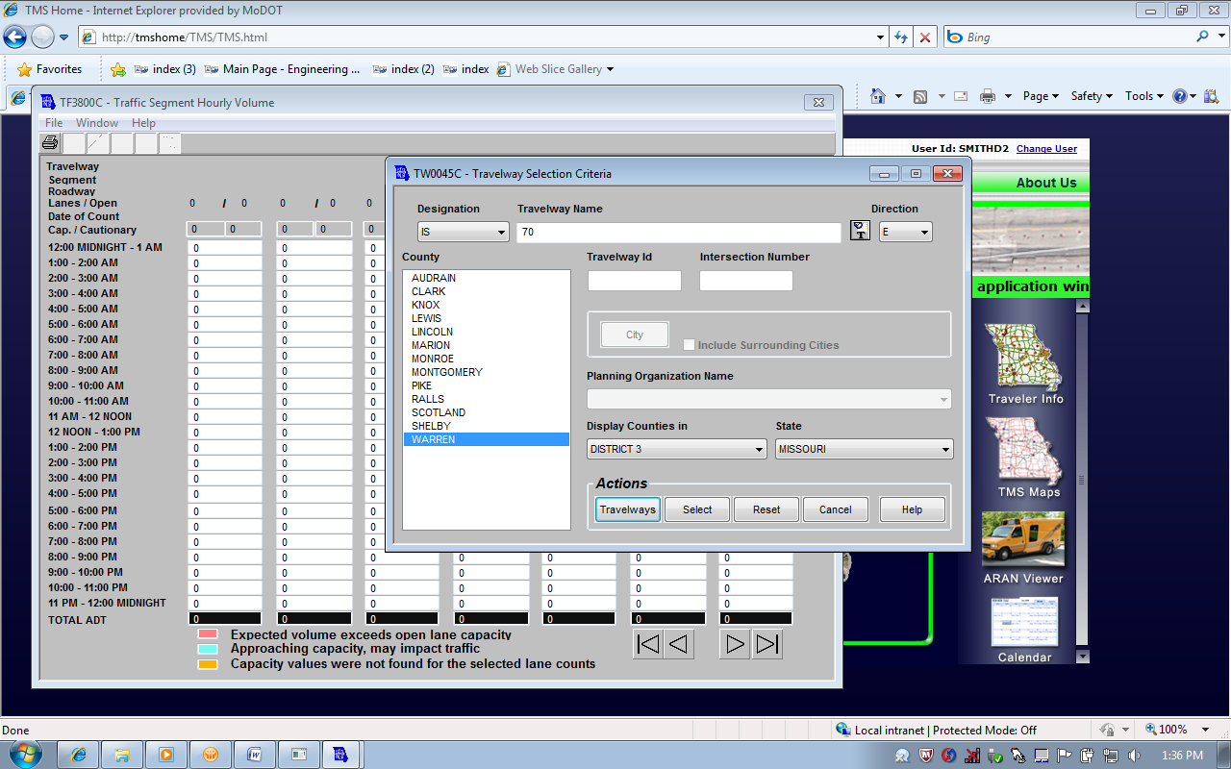
15. Select the location that you are interested in, Begin Log is located at MO 47. Highlight the location of interest and then click either “Begin Log” or “End Log” tab. Then click on “Select” tab.

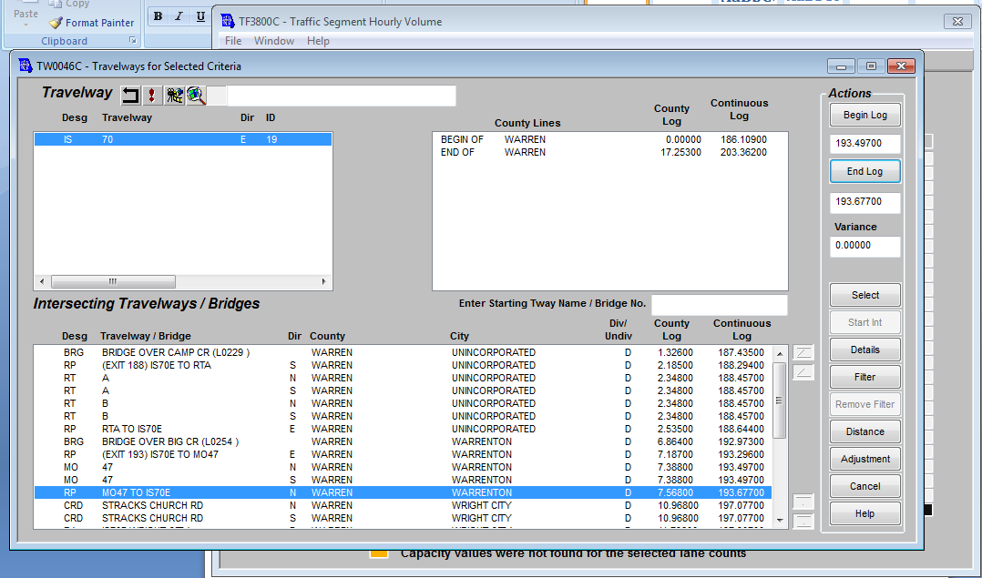

16. Once selected the hourly volume table appears with the cautionary zone (blue) and capacity restriction (red) levels.
17. The binocular tab in the upper left provides the ability to view calculated hourly volume for past and future time periods.
18. Click on the binoculars.

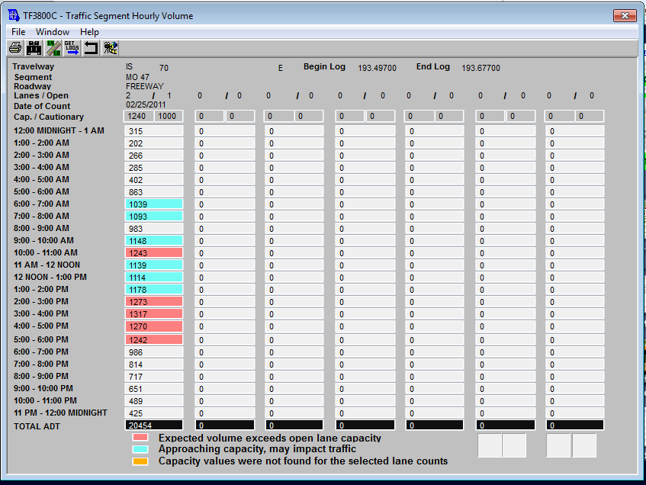
19. The Hourly Volume Search Criteria can provide hourly volume for different dates, this example is for a week in June of 2011.

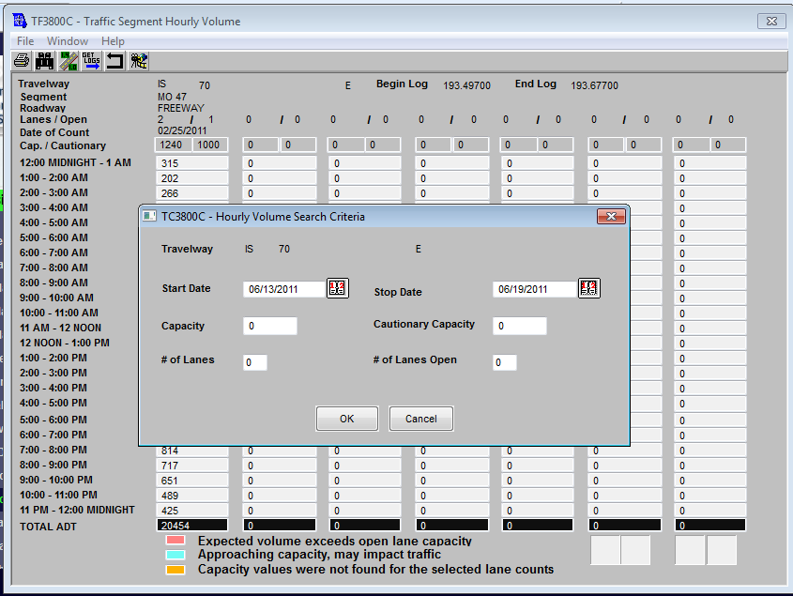

20. A full week of hourly volume is present.

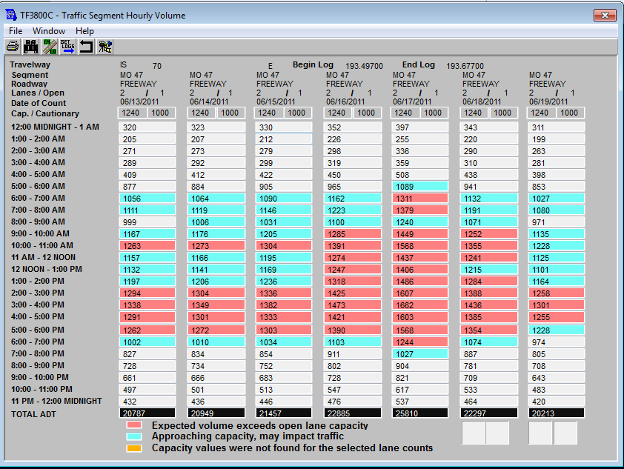

21. To save this information, click on “File” and then go to “Print” and then to “Print Contents to File”.
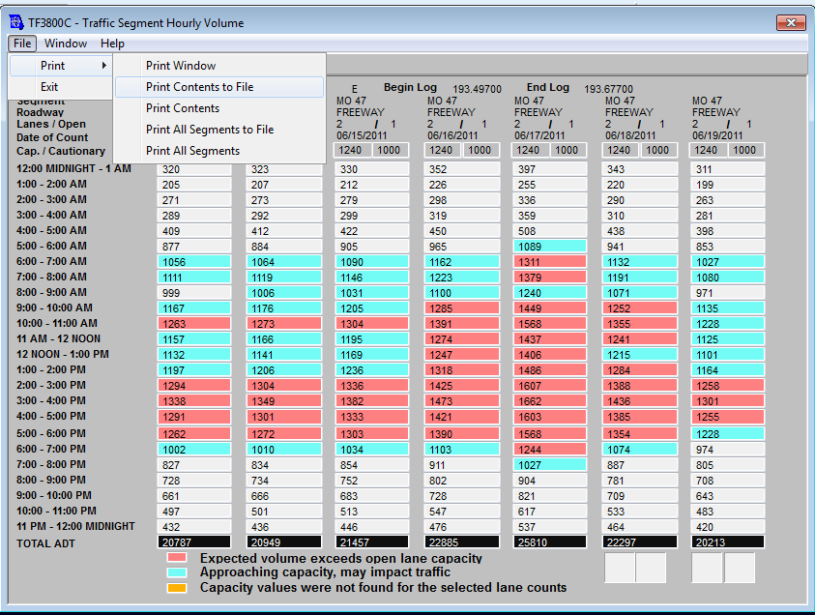

22. The information is saved in a workable Excel sheet, which can be imported into the “MoDOT Work Zone Impact Analysis Spreadsheet”.