Last updated 7/29/2026

Historic Preservation Section

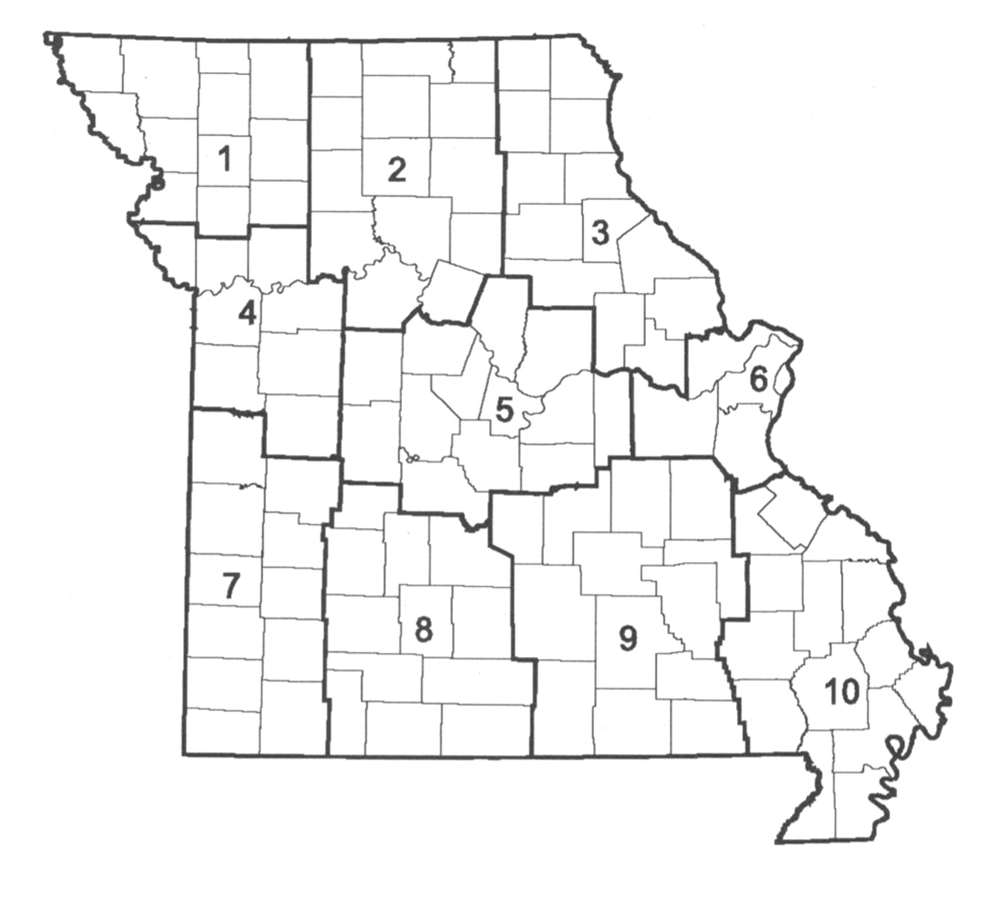
Robert L. Reeder (REEDER1) Mailing Address:
Historic Preservation Coordinator
TIM REDMOND
573-751-0473 601 W. Main St.
3rd Floor
Michael C. Meinkoth (MEINKM) Jefferson City, MO 65102
Assistant Historic Preservation Coordinator

MIKE
STELZLENI
573-526-3593

JIM
SSMITH

JIM SMITH

Becky Weems (WEEMSR) FAX: 573-526-1300

CHARLES PURSLEY
Senior Office Assistant
TIM
REDMOND
573-526-3597

To e-mail us:
firstname.lastname@modot.mo.gov

District
Title Contact Phone Assignment Userid

Senior Historic Aaron Anglen 573-526-3594 ANGLEA
Preservation Specialist Larry Ayres 573-526-7836 3,5,7,8,9 & 10 AYRESL
(Archaeologist) James Harcourt 573-526-3562 1,2,4 & 6 HARCOJ Michael Meyer 573-526-3560 MEYERM2
Rusty Weisman 573-526-3590 WEISMR

Senior Historic Karen Daniels 573-526-7346 3,6,8,9 & 10 DANIEK1
Preservation Specialist Toni Prawl 573-526-3598 1,2,4,5 & 7 PRAWLT
(Architectural Historian)

Senior Historic Randy Dawdy 573-526-3591 DAWDYR

Preservation Specialist
(Historic Bridge Coordinator)
Sue Olson 573-526-3559 1,2,3,5 & 6 OLSONS
Senior Cartographer Pam Schmutzler 573-526-3561 4,7,8,9 & 10 SCHMUP

Senior Historic Dave Austin 573-526-3595 3,6,8,9 & 10 AUSTID
Preservation Specialist Tom Gubbels 573-522-5554 1,2,4,5 & 7 GUBBET
(Historian)
Jack Eastman 573-526-7905 EASTMJ
Larry Grantham 573-522-5557 GRANTL1
Intermediate Historic Jane Lee 573-522-9695 LEEJ4
Preservation Specialist Brianne Olson 573-526-7908 OLSONB1
(Archaeology Assistant) Terry Martin 573-522-5556 MARTIT
Rick Rahe 573-526-7907 RAHER1
Travis Tesreau 573-526-3592 TESRET1

Chris Koenig 573-751-6752 KOENIC1
Historic Preservation Specialist Ron Mayer 573-751-5184 MAYERR1
(Archaeology Field Assistant) Tim Porter 573-526-7906 PORTET2

