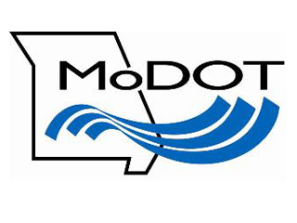
District 3

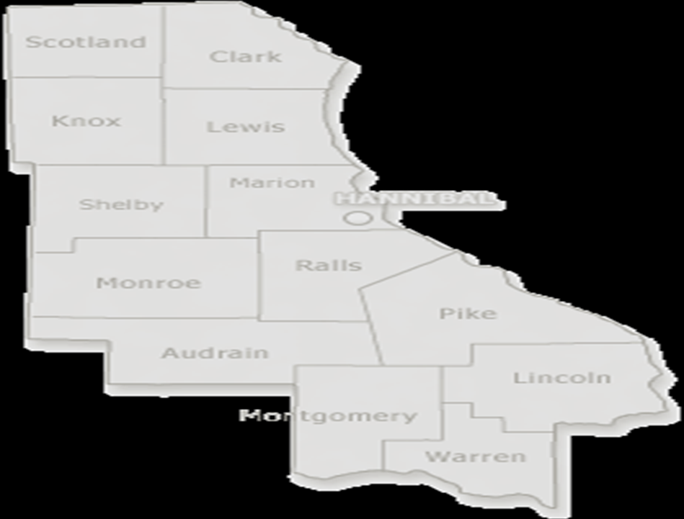

Transportation
Enhancements

Table of Contents
A Guide to Transportation Enhancements

Page

I. Transportation Enhancement Activities 2

II. Project Eligibility Requirements 8

III. Important Information for Applicants 8

IV. Project Selection 9

V. Progress Requirement 10

VI. Application 12

VII. District Contacts 20

VIII. TMA and MPO Contacts 21

IX. Program Rating Sheet 22

X. Schedule for Project Selection and Programming 23

A Guide to Transportation Enhancements
Missouri Department of Transportation
September 2010

Congress created the Transportation Enhancement Program in 1991. The program requires each state to reserve 10 percent of its Federal Surface Transportation Program funds annually for designated Transportation Enhancement activities to ensure transportation spending supports more than just roads.

Transportation Enhancement funds are available to develop a variety of project types located in both rural and urban communities. The projects help create more travel choices by providing funding to construct sidewalks and bike lanes, and to convert abandoned railroad rights of way to trails. Communities may also use the Transportation Enhancement Program to revitalize local regional economies by restoring historic buildings, renovating streetscapes or providing transportation museums and visitor centers.

This guide will help an applicant through the application process. It provides tips for meeting state and federal requirements, and explains how a project progresses from start to finish.

Transportation Enhancement Activities

There are 12 possible transportation enhancement activities, which have been grouped into three categories by common characteristics. The following list of enhancement activities includes examples of each type of project. This list of projects is not comprehensive, but it offers examples of how transportation enhancement funding can be used. Although the federal government provides guidance and ensures compliance, states are responsible for selecting their own enhancement projects. To discuss specific eligibility guidelines, contact the local coordinator for the applicant’s area identified on pages 20 and 21 of this document or view http://www.modot.mo.gov/business/manuals/documents/D3Guide.pdf on the Internet.

Bicycle and Pedestrian Group

Pedestrian and Bicycle Facilities: This category provides funding for new or reconstructed sidewalks, walkways, curb ramps, bike-lane striping, wide paved shoulders, bike parking, bus racks, off-road trails, bike and pedestrian bridges, and underpasses.

City of St. James Hiking and Biking Path
City of St. James

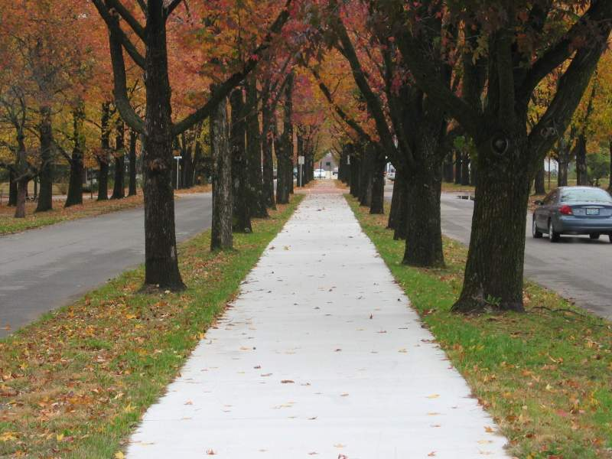

The city of St. James’ path consists of 10,520 feet of bicycle and pedestrian path, 5,055 feet of new curb and 75 curb ramps. This project allows bicyclists and pedestrian’s access to commonly used community facilities. Bicycle and pedestrian facilities must adhere to the Americans with Disabilities (ADA) standards.

Pedestrian and Bicycle Safety and Education Activities: These programs are designed to encourage walking and bicycling by providing education and safety instruction to potential users through classes, pamphlets and signage.

Missouri River Bridge

Missouri Department of Transportation

Jefferson City

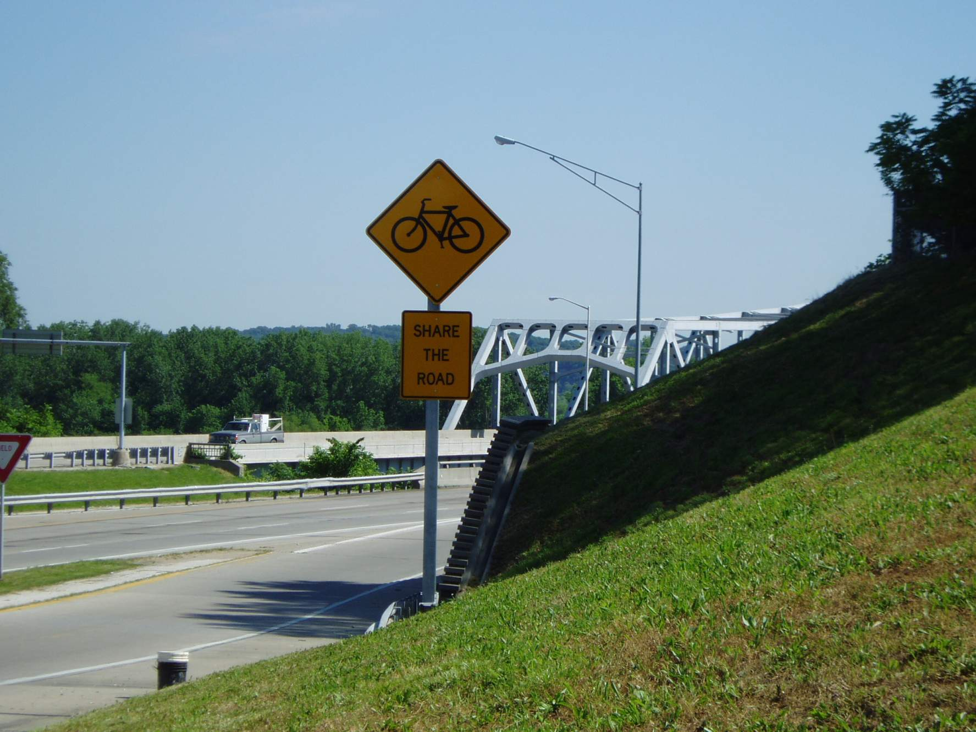

Providing Share the Road signs is an example of a project that can be funded in this category. This project provided Share the Road signs, bike-safe grates and roadway striping for a bike lane on the Missouri River Bridge in Jefferson City.

Conversion of Abandoned Railway Corridors to Trails: This category provides funding for acquiring railroad rights of way; planning, designing and constructing multi-use trails; and developing rail-with-trail projects.

Urban Trail Corridor – Phase 7
City of St. Joseph

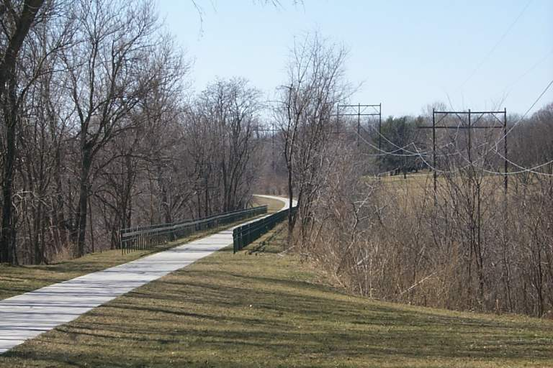

The St. Joseph Urban Trail is located on the historic Chicago and Rock Island Railroad corridor, connecting 9.2 miles of the St. Joseph Parkway System. This project converted the unutilized railway corridor to a bicycle and pedestrian facility that provides an east-west link to existing trails and sidewalks within the city of St. Joseph.

Scenic and Natural Resources Group

Scenic or Historic Highway Programs Including Tourist and Welcome Centers: This category provides funding for the construction of turnouts, overlooks, visitor centers, viewing areas, and designation signs and markers.

Lewis and Clark Historical Marker Signs
Missouri Department of Transportation

Charleston

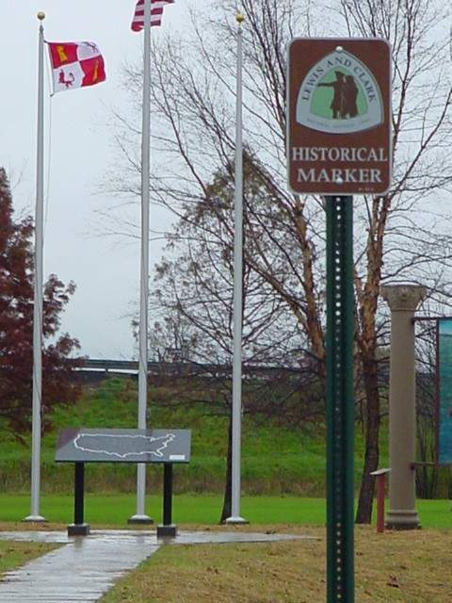

The Lewis and Clark Historical Marker signs project provides signs commemorating the bicentennial of the Lewis and Clark Expedition.

Acquisition of Scenic or Historic Easements and Sites: This category provides funding for acquiring scenic land easements, vistas and landscapes; acquiring historic battlefields; purchasing buildings in historic districts or historic properties; and preserving farmland.

Acquisition of the Rice-Tremonti House

City of Raytown

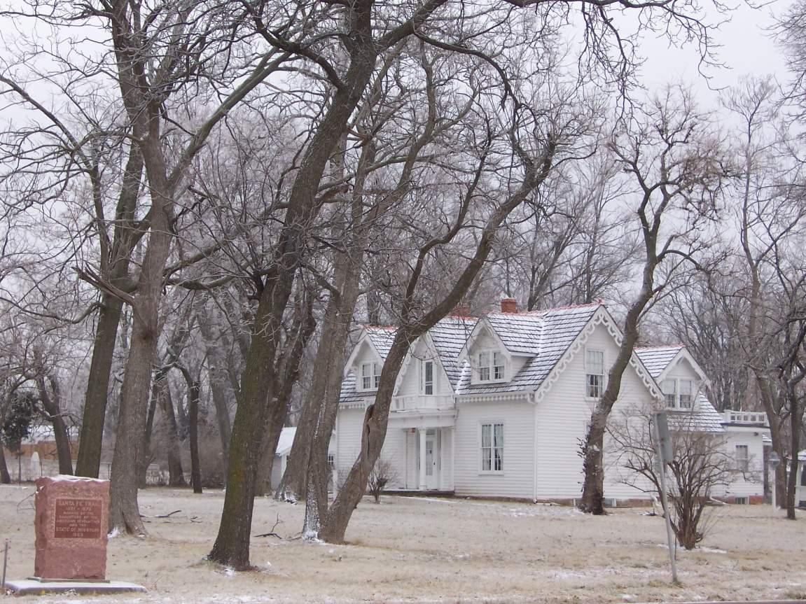

The Rice-Tremonti House property is located along the historic routes of the Santa Fe, Oregon and California trails. It is located in the city of Raytown at the intersection of 66th Street and Blue Ridge Cutoff (Old Santa Fe Road). This project acquired, preserved and provided public access to a 3.6-acre historic site and associated buildings located on the primary route of these three nationally significant historic trails. This project made an historic site available to the public in perpetuity. The city permanently owns, maintains and operates the property as a public park and museum.

Landscaping and Scenic Beautification: This category provides funding for improvements such as street furniture, lighting and public art, and landscaping along streets, historic highways, trails, interstates, waterfronts and gateways.

Delmar Community Pathway
City of St. Louis

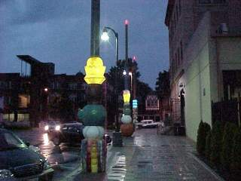

The project consists of seven icon poles that include a series of art elements. Four of the poles contain recognizable images from the Delmar Loop rendered in glazed ceramic. The other three poles consist of ceramic cylinders with geometric patterns. On top of each ceramic stack is a light shade made of translucent fiberglass that conceals a 120-volt light.

Control and Removal of Outdoor Advertising: This category provides funding for billboard inventories or removal of illegal and nonconforming billboards.
Billboard Baseline Inventory
Missouri Department of Transportation

Jefferson City

The project provides the equipment needed to create a billboard baseline inventory. The inventory will be updated periodically and will be used to control outdoor advertising.

Environmental Mitigation of Runoff Pollution and Provision of Wildlife Connectivity: This category provides funding for runoff pollution studies, soil erosion controls, detention and sediment basins, river clean-ups and wildlife crossings.
Upper Jordan Creek Greenway
City of Springfield

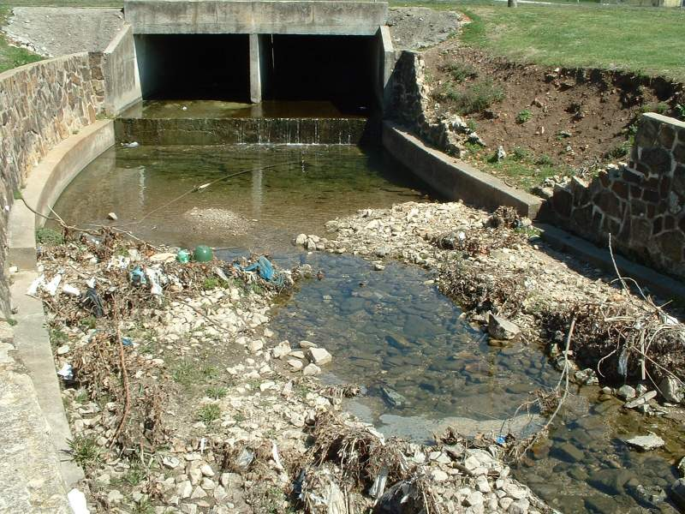

The Upper Jordan Creek Greenway Project develops land purchased by the city of Springfield for stormwater improvements. This project makes improvements to the water collection facility in order to help prevent erosion and pollution in the creek. It includes the naturalization of the current concreted channel and the upgrading of four box culverts. It also includes 5,000 feet of asphalt trail for bicycles and pedestrians. This project connects two parks, neighborhoods, schools, colleges and businesses. It also creates a link under Chestnut Expressway and to the downtown Jordan Valley Park area.

Historic and Archeological Group

Historic Preservation: This category provides funding for preservation of buildings and facades in historic districts, restoration and reuse of historic buildings for transportation-related purposes and pedestrian access improvements to historic sites and buildings.

Hannibal Mark Twain Area

Restoration Project
City of Hannibal

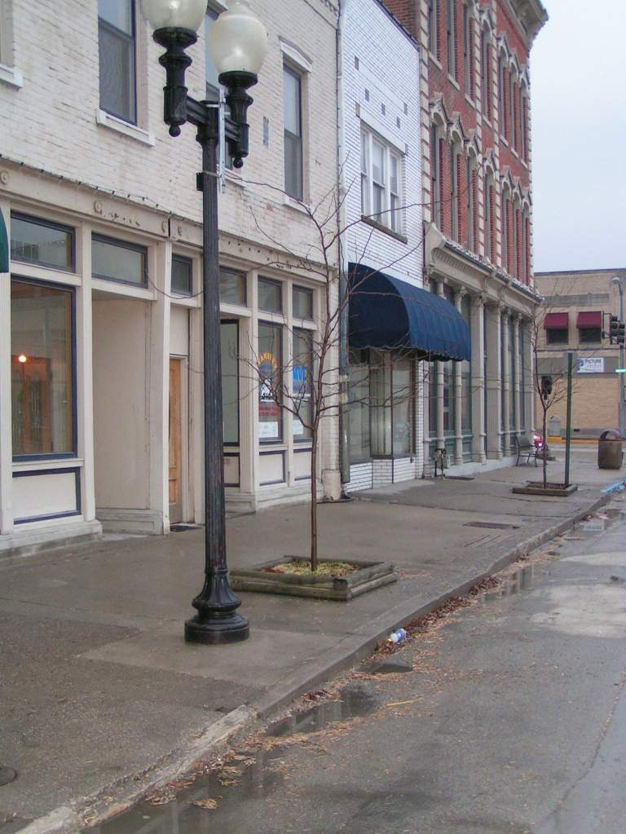

The Hannibal Mark Twain Area Restoration Project provides historic lighting on approximately seven blocks of Broadway Street in Hannibal. This project is part of the Hannibal Mississippi River Front Master Plan adopted by the city of Hannibal in May 1995.

Rehabilitation and Operation of Historic Transportation Buildings, Structures or Facilities: This category supports the restoration of railroad depots, bus stations and lighthouses, and the rehabilitation of rail trestles, tunnels and bridges.

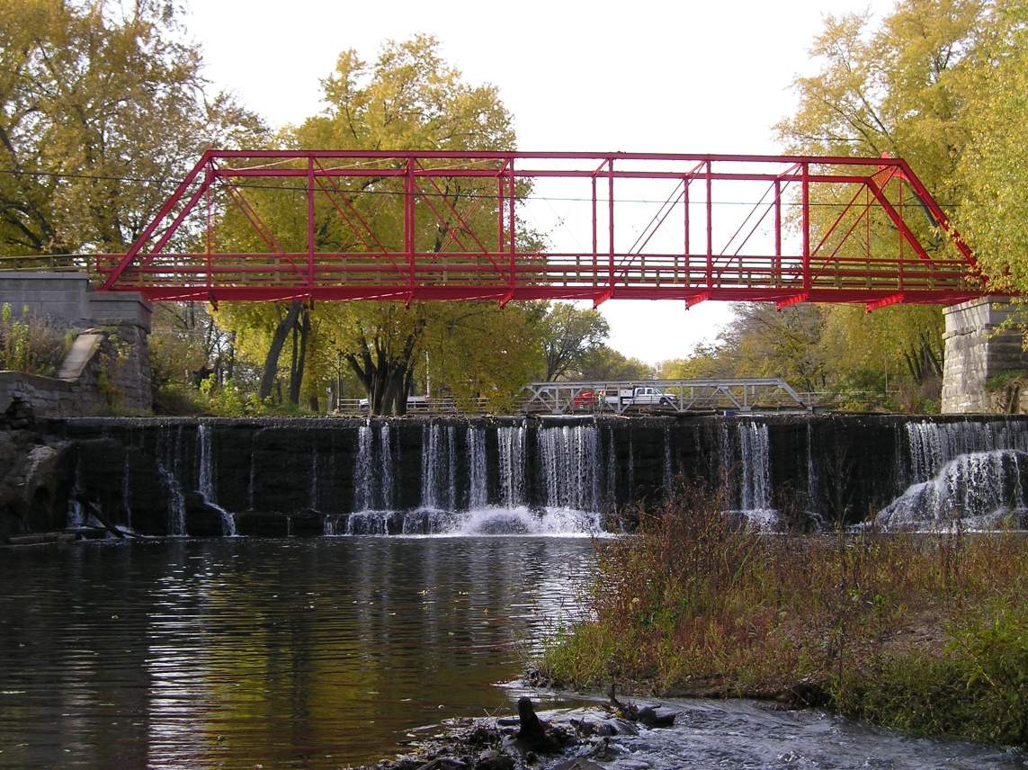

Restoration of the Old Appleton Bridge

Village of Old Appleton

The Village of Old Appleton Pedestrian and Bicycle Bridge Project restored this bridge constructed in 1879 by H. W. Sebastian and Company of St. Louis. A record flood washed the bridge off its piers and over the milldam in 1982. This project restored and remounted the bridge on higher pilings and makes the crossing accessible to bicyclists, pedestrians and equestrians. This project will improve the safety of the Lower Mississippi Delta Trail.

Archaeological Planning and Research: This category helps fund research; preservation planning and interpretation; developing interpretive signs, exhibits and guides; and inventories and surveys.

Although Missouri has not funded a project in this category, possible projects could include archeological investigations providing historical insight into the development and evolution of the early transportation networks in the United States.

Establishment of Transportation Museums: This category supports construction of transportation museums, including the conversion of railroad stations or historic properties to museums, with transportation themes and exhibits or the purchase of transportation-related artifacts.

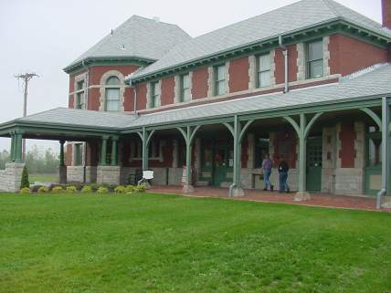

Sedalia Katy Depot / Railroad

Heritage Museum
City of Sedalia

The Railroad Heritage Museum is located in the Sedalia Katy Depot. This project renovated the Sedalia Katy Depot and provides a welcome area, museum office and four exhibit galleries. The grounds include interpretive exhibits with restored rolling stock and rail sculptures. The depot is listed on the National Register of Historic Places. The project is accessible to bicycle and pedestrian visitors along the Katy Trail State Park.

Project Eligibility Requirements

To sponsor a Transportation Enhancement project, an applicant must follow the state and federal rules for using federal funds. The state and federal guidelines for these projects can be found in the Local Public Agency Manual at http://www.modot.mo.gov/business/manuals/localpublicagency.htm#LPAManual and the Code of Federal Regulations, respectively. A Transportation Enhancement project must adhere to the following guidelines. Local committees can apply tighter guidelines at their discretion. Please contact the appropriate MoDOT district staff listed on page 20 of this guide for more information.

- Meet at least one of the 12 transportation enhancement activities
- Have a direct relationship to an intermodal transportation system in terms of function, proximity or impact
- Involve activities that are over-and-above normal transportation practice
- Provide public access for at least 25 years
The property must be either owned by the project sponsor or involve a permanent lease.
- Have a project maintenance plan for at least 25 years
- Be sponsored by a local government or public agency
If the applicant is a state or federal agency, then the applicant must include a resolution from the local governing councils or commissions supporting the project.
- Meet the minimum project size of $50,000 in federal funding for enhancement projects, per District 3 local committee requirements
- Provide a local match of at least 20 percent of the total project cost or the minimum required by the local committee
- Minimum total project cost is $62,500. This includes the $50,000 in federal funds and $12,500 in local match, assuming that a 20 percent match is required.
- The maximum federal funds per application will be $200,000. Projects of greater cost may be eligible for selection if the local agency will commit to providing the additional funds.
- Be governed by the Local Public Agency Manual and other design guidance adopted by the local committees.

Important Information for Applicant

Project sponsors should keep in mind the following information.

- This program reimburses the project sponsor for costs incurred. It does not provide money up front.
- A large or expensive project may be split into phases. Each phase must be applied for and approved individually.
- The funds allocated to a project are fixed. The project sponsor must pay all costs incurred in excess the funding allocated to the project. Therefore, it is important to develop a good estimate for the project application.
- The majority of projects will go through a competitive bid process for construction. In some cases, construction may be done by volunteer or public forces.
- One application will be accepted per political sub-division, and the project must be owned, operated and maintained by the applicant.
- Application deadline for submission to MoDOT District Personnel (See page 20 for address) is December 15, 2010.
Project Selection

To encourage public involvement in transportation planning, there are two distribution processes: Statewide Competitive and Local Competitive.

In this round, which utilizes MoDOT’s 2010 and 2011 Enhancement federal allotment, 17.6% of the two year’s allocation is provided to the statewide process. This process will focus on funding projects on MoDOT right of way.

The remaining 82.4% of the funds are distributed to the Transportation Management Areas (TMA) and MoDOT districts based on relative population. TMAs are metropolitan planning organizations for areas with a population greater than 200,000. Each TMA has developed its own process for project selection. Currently, Missouri has three TMAs (EWGCOG – St. Louis area, MARC – Kansas City area, and OTO – Springfield area). Outside the TMAs, each MoDOT district will identify a local selection committee.

The local selection committees will be able to set aside funds for emerging needs. The committees have the authority to decide the amount withheld for emerging needs. The committees also have the authority to determine the maximum project size and others factors.

Example of Funding Distribution
Selection Process | % Population | Fall 2010
Statewide (17.6%) |  | $7,045.000
Local (82.4%) |  | $32,847,870
St. Louis (EWGCOG) | 34.68% | $11,391,642
Kansas City (MARC) | 16.36% | $5,840,352
Springfield (OTO) | 4.62% | $1,517,572
District 1 | 3.61% | $1,185,808
District 2 | 3.17% | $1,041,278
District 3 | 3.59% | $1,179,238
District 4 | 2.26% | $742,362
District 5 | 8.09% | $2,657,392
District 7 | 5.88% | $1,931,454
District 8 | 4.65% | $1,572,426
District 9 | 4.61% | $1,514,286
District 10 | 7.06% | $2,319,060
Total | 100.00% | $40,000,000

The population data used in the distribution of funding is based on the Census 2000. It will not be updated based on census projections. The next revision to the population data will come from the 2010 census.

The local application process steps are as follows.

- Solicit for project applications.

The application included in this guide should be used for the statewide process. Applications for the local and TMA processes may be modified. The MoDOT district enhancement fund representative will be able to supply applicants with the correct application and number required. See page 19 for the list of contacts.

- Applications will be reviewed and rated by the appropriate selection committee. Funding will be applied to the projects selected by the committee. In the event the project cost exceeds the available funding, the applicant will have the option to (1) fund the unfunded amount, or (2) remove the project from consideration.

The local committee membership will be diverse. It will consist of six members.
The local committee may include representatives from Regional Planning Commissions, Metropolitan Planning Organizations, historic preservation advocate, bicycling advocate, pedestrian advocate, water quality advocate, architectural landscaping advocate, Missouri Department of Transportation, Department of Natural Resources, Missouri Department of Conservation and Federal Highway Administration.

- MoDOT staff will notify the applicant of the committee’s decision.

Progress Requirement

Any project selected will need to have preliminary design completed by December 31, 2011. Construction will be completed in Calendar Year 2012.

Application Instructions

The application, application deadline information and corresponding guidance are available from any MoDOT district office, the MoDOT Central Office in Jefferson City or on the MoDOT Web site at http://www.modot.mo.gov/business/manuals/localpublicagency.htm. Projects in areas with a population greater than 50,000 must also submit an application to the appropriate Metropolitan Planning Organization. All applications must be postmarked by close of business on the designated application deadline day. (TMA, MPO and MoDOT district contact information is located on pages 20 and 21)

- Local projects: Submit the specified number of copies to the appropriate TMA or district contact.
- Applications must be typed. The application can be found at http://www.modot.mo.gov/business/manuals/localpublicagency.htm. in electronic format.
- Project applications should be stapled in the upper left-hand corner. Do not use covers, binders, tabs or any other device.

Tips for successful applications include the following.
- Demonstrate how you can meet project completion deadline – End of 2012
- Plan for cost increases and inflation
- Plan for long-term maintenance
- Check and double-check application for completeness and accuracy
- Be creative
- Provide photographs of the proposed project location
- Determine if the project complies or conflicts with MoDOT’s Long-Range Transportation Plan and Statewide Transportation Improvement Program, and any local or regional long-range plan or Transportation Implementation Program
- Review all of the scoring procedures, and answer all questions


TRANSPORTATION ENHANCEMENT FUNDS
PROGRAM APPLICATION
2010/11 District Competitive
STP # (to be assigned by MoDOT) Application Date: __________

Date Approved:

A. PROJECT SPONSOR INFORMATION

First Sponsor Name: __________________________________________________________________
Contact Person: _______________________________________________________________________
Title: ________________________________________________________________________________
Address: City: ______________State: Zip: _________
Phone: Fax: Email:

Second Sponsor Name: ________________________________________________________________
Contact Person: _______________________________________________________________________
Title: ________________________________________________________________________________
Address: City: ______________State: ______ Zip: ________
Phone: Fax: Email:

B. BASIC PROJECT INFORMATION

Project Title:
District Number: County: ________________________________________________
Metropolitan Planning Organization (if applicable): ___________________________________________

Will the project be open to the public for at least 25 years? Yes No

Will a fee be charged for public access? If yes, how much? _________ Yes No
If yes, explain how the fees charged will be used.

C. PROJECT LOCATION INFORMATION

1. Where is the project located? Attach a map no larger than 8 ½ inches by 11 inches.

2. Please check the appropriate box for each question.

Is the project a component or extension of a

previously awarded transportation enhancement project?
If so, give the project # : STP- Yes No

Does all right of way necessary for the project fall within

public ownership or lease? Yes No

- Does the project sponsor own the right of way? Yes No

- If no, does the applicant have an option on the property
executable within one year of application? Yes No

- Have utilities been cleared or considered for the project? Yes No

- If right of way acquisition is necessary, is the applicant
willing to exercise condemnation authority to acquire? Yes No

- Does the Applicant have any uncompleted enhancement
projects outstanding? Yes No

D. ENHANCEMENT CATEGORIES BY GROUP
Check all that apply. A project may overlap groups.
1. Bicycle and Pedestrian Group
Transportation facilities for pedestrians and bicycles
Safety and educational activities for pedestrians and bicyclists
Preservation of abandoned railway corridors, including conservation and use thereof for pedestrian and bicycle trails

2. Scenic and Natural Resources Group
Scenic and/or historic highway programs, including the provision of tourist and welcome centers
Acquisition of scenic easements and scenic or historic sites including historic battlefields
Landscaping and other scenic beautification
Control and removal of outdoor advertising
Mitigation of water pollution due to highway runoff, including projects that reduce vehicle-caused wildlife mortality, while maintaining habitat connectivity

3. Historic and Archeological Group
Historic preservation
Rehabilitation and operation of historic transportation buildings, structures or facilities
Archaeological planning and research
Establishment of transportation museums

E. Project Description
Please provide a concise overview of the project. Include major components such as project width, length and material types. Include the cause of the need and a description of existing facilities. Deferred maintenance is not a legitimate cause of need. Identify any environmental or cultural resource considerations. Describe the project’s link to surface transportation. Drawings no larger than 8 ½ inches by 11 inches may be attached to the back of this application.

ADDITIONAL INSTRUCTIONS: The project description provides a concise overview of the proposal. Describe the overall concept of the project. Include major components such as width, length and material types. Other items to note include creative or innovative designs, safety features, maintenance standards or unique features. All applicants are required by law to comply with the Americans with Disabilities Act (ADA) of 1990. Applicant must refer to the Uniform Federal Accessibility Standards (UFAS) and the Americans with Disabilities Act Accessibility Guidelines (ADAAG) for complete details on making the project accessible (if applicable).

The applicant is required to also follow any state and local accessibility codes. Drawings no larger than 8 ½ inches by 11 inches may be attached.
All projects funded through the Transportation Enhancements Program must have a link to the surface transportation system – highways and roads, railroads and bicycle or pedestrian facilities. Surface transportation includes transport by both land and water. Transport by water encompasses features such as canals, lighthouses, and docks or piers connecting to ferry operations.

A project must have a strong link to surface transportation in order to adequately compete for this funding. The relationship that the project has to surface transportation may be a combination of function, proximity and/or impact.

- Function – The project will serve as a functional part of the transportation system; for example, the construction of bicycle and pedestrian facilities.
- Proximity – The project is located within the immediate vicinity of the transportation system and may be visible to the general public, such as the acquisition of scenic easements or landscaping. Proximity alone is not enough to establish the relationship to surface transportation. For example, a hotel located adjacent to a state highway would not automatically be eligible to receive enhancement funds just because it is located within the view of the highway.
- Impact – The project has a physical impact on the transportation system, such as retrofitting an existing highway by creating a wetland to filter runoff from the highway. In this example, the enhancement funds would be used to mitigate the pollution from the runoff. Projects with this type of transportation relationship are usually associated with ongoing or planned highway projects.

F. GENERAL COST ESTIMATE
List the cost of the applicant’s project components in the table provided below. Not all budget categories may apply to all projects. Transportation enhancement funds can reimburse up to 80 percent of the total project cost. Non-federal matching funds may come from the applicant's resources or from a third-party donation to the applicant for cash, materials or labor. The minimum federal share request is $50,000. (Tip: Add the rows across, and then add the columns down. Both sums should be the same and equal the total project cost in the bottom right-hand corner of the grid).

Please round to the nearest hundred dollars.

LIST OF ITEMS  IN ORDER OF COMPLETION | Federal Share Request | NON-FEDERAL MATCH |  | Total  (Add each row)
LIST OF ITEMS  IN ORDER OF COMPLETION | Federal Share Request | Applicant Budget | Donation | Total  (Add each row)
1. Right of Way Acquisition | $ | $ | $ | $
2. Labor / Construction | $ | $ | $ | $
3. Utility Relocation | $ | $ | $ | $
4. Materials | $ | $ | $ | $
5. Design/Preliminary Engineering | $ | $ | $ | $
(No more than 10% of items 2-4 above)
6. Construction Engineering | $ | $ | $ | $
(No more than 15% of items 2-4 above)
7. Construction Contingency (No more than 10% of items 2-4 above) | $ | $ | $ | $
 | $ | $ | $ | $
TOTALS | $
(Add each column) | $ | [BOX 1] | [BOX 2] | [BOX 3]

To determine applicant federal share request:
X 100% = % (20% minimum)
=
(BOX 1 + BOX 2)/BOX 3

Note: Please attach an additional sheet detailing the costs described above. If applicable, describe all local groups/agencies that will complete work as part of the applicant’s plan.

Name and title of individual who prepared the cost estimates for this project:

Printed Name of Preparer Preparer’s Title Phone Number

Preparer’s Signature Date

ADDITIONAL INFORMATION: In the cost estimate section of the application, several categories have been set up in which to enter information pertaining to the project. Most project costs will fall into these categories.

Try to break down the project costs into the specific cost categories. For example, “$80,000 for landscaping” without stating how much is for materials, labor or equipment is not acceptable. If information submitted in a proposal is unclear, the application may not be scored correctly.

Break down the costs for each category in the appropriate columns according to who will pay for that portion – either the federal share (to be reimbursed), the sponsor (as non-federal match) or a third party donation (as non-federal match). As an example: An applicant anticipates trail materials will cost $30,000 total. The applicant is receiving $5,000 in trail materials donated by the supplier. The federal share is $20,000, and the applicant’s organization will pay $5,000. The applicant’s organization’s staff will provide the labor for the project, which is expected to cost $20,000, but the applicant wants half of the cost to be reimbursed. The budget table for this example would be as follows.
 | Federal Share Request | Non-Federal Match |  | Total
 |  | Applicant Budget | Donation
Trail Materials | $20,000 | $ 5,000 | $5,000 | $30,000
Labor | $10,000 | $10,000 |  | $20,000
 | $30,000 | $15,000 | $5,000 | $50,000

In this example, the total project cost is anticipated to be $50,000, and the federal share will cover $30,000, or 60 percent. The match is $20,000, with $15,000 covered by the sponsor and $5,000 donated by a third party.

Design and preliminary engineering costs are allowable, but they are limited to no more than 10 percent of the utility relocation, materials, labor and construction costs. Contingencies are allowable on construction costs only and are limited to no more than 10 percent of the utility relocation, materials, labor and construction costs. Construction engineering costs are allowable for construction costs only and are limited to no more than 15 percent of the utility relocation, materials, labor and construction costs.

Attach one additional sheet that details the costs. Remember the transportation enhancement funding is a reimbursement program, so the applicant must have funding available for the non-federal match and the federal share. Be sure to indicate the specific source(s) for the applicant’s non-federal match. Non-federal match may come from private fund donations, city or county funds, force account or in-kind services. Describe any additional funds that will be used if the project cost exceeds those estimated in the general cost-estimate. The person who prepared the cost-estimate must sign in the space provided at the bottom of the page.

G. SAFETY IMPACTS - (10 points)
Describe the impact and effectiveness of the project, in terms of how it will improve safety.

H. RELATIONSHIP TO SURFACE TRANSPORTATION - (20 points)
This Section relates to the category groups listed in Section D of this application. (See Page 12 of this application) Describe how your project, regardless of the category, provides connectivity and/or relationship to surface transportation. Please describe for a pedestrian facility the origin and termini along with the key facilities along the route (if a pedestrian facility), or describe how the proposed project is related to transportation systems. Additional aspects to consider include, but are not limited to, filling network gaps, accommodating the appropriate level of transportation use, providing access to specific destinations, eliminating transportation barriers and providing a viable alternative to motorized travel. Describe how the project will meet the need(s) identified by the applicant.

I. Local Long-Range Plan - (5 points)
How does the proposed project coordinate with existing local, regional or statewide long-range plans? Is it a project that has support from your Regional Planning Commission?

J. CASH MATCH AND WORK BY LOCAL FORCES - (10 points)
All 10 available points will be given to those applicants that can come up with the required 20% match with cash or work by local forces. Donated materials and labor by volunteers are acceptable, but not preferred. At the discretion of the committee, reduced points will be given for the latter.

K. LAND RIGHTS – (5 points)
What percentage of easements are currently acquired? Discuss if proposing to utilize MoDOT right of way. Remember, if utilizing MoDOT’s property, prior approval must be given from District 3 office personnel before application is submitted.

L. COMMUNITY IMPACT - (10 points)
Describe the support the sponsor has garnered from key stakeholders in this project. Describe their feelings or, preferable, include letters of support. Describe any anticipated opposition to the project and how that opposition will be addressed.

M. LONG-TERM MAINTENANCE
What governmental entity will be responsible for the short- and long-term project maintenance? Identify all maintenance participation and the source of funds supporting long-term maintenance. Will the project sponsor be able to maintain the project for a minimum of 25 years? Yes No

Complete the following maintenance activity table:

Maintenance Task Task Cost Frequency Annual Cost
1. $ $
2. $ $
3. $ $
4. $ $
5. $ $
TOTAL ANNUAL MAINTENANCE COST $_________

EXAMPLE
Maintenance Task Task Cost Frequency Annual Cost
- Sweep trail $ 300 Monthly, May-Oct. $ 1,800
- Mow grounds $ 550 Weekly, May-Oct. $13,200
- Empty trash containers $ 100 Twice weekly $ 5,200
- Tree trimming $ 450 Once per year $ 450
- Plant native species $2,000 Once per year $ 2,000
TOTAL ANNUAL MAINTENANCE COST $22,650

N. APPLICANT EXPERIENCE – (5 points)
Briefly describe the agency’s ability to manage state or federal grant funding, including but not limited to Transportation Enhancement funds.

O. PAST EFFORTS TO ADDRESS NEED - (10 points)
Include what efforts the sponsor has done previously to address the need.

P. Environmental and Cultural Resource Considerations
If the project involves any of the following natural or cultural items, the applicant may, after project approval, be required to obtain specific permits and clearance forms to ensure compliance with local, state and federal requirements. This list may not be all-inclusive.

Will the project involve:
- Historic buildings or archeological sites? Yes No
- Existing parks and recreation areas? Yes No
- Designated or undesignated wetlands and/or swamps? Yes No
- Creeks or rivers? Yes No
- Stream straightening and/or crossing? Yes No
- Lakes or ponds? Yes No
- Known hazardous materials and/or waste? Yes No
- Floodplains? Yes No

For all “yes” answers, explain any preventative measures the applicant will take to avoid negative impacts during or after the implementation of the project.

ADDITIONAL INFORMATION: It is the project sponsor’s responsibility to be aware of all necessary permits and clearances required prior to project approval. While the project is in the planning stage, make an assessment of potential negative impacts the project may have to the area. Although the applicant may not start the permit/clearance process until after receiving approval to begin design, there are preventative and/or corrective measures that can be taken to avoid negative environmental or cultural resource impacts to the project area.

For all “yes” boxes checked on the application form under this section, describe what steps applicant will take to avoid negatively impacting the applicant’s project location. If the applicant answered “no” to all the questions under this section, describe other ways the applicant plans to mitigate the negative impacts at the project location.

Examples of preventative and corrective measures include, but are not limited to, rehabilitation of a disturbed area using native plant species, creation of wildlife food plots to minimize vehicle-caused wildlife mortality, stream bank stabilization (when connected in some way to surface transportation), controlled public access to certain sensitive environments, scheduled clean-ups throughout the project to prevent the spread of pollution or damage to the work area, and providing for proper drainage to lessen the effects of erosion due to an increase in impermeable surfaces.

Q. Application Clarity and Completeness – (5 points)
The application may be given up to five points for its overall clarity and how complete the application and cost estimate are. A good application does not need to be lengthy. A clear, concise application will also reduce the potential for confusion.

R. PROJECT READINESS - (10 points)
Describe how “shovel-ready” the project is to proceed.

S. PROJECT TIMELINE - (5 points)
Based on all details described in this process, does the applicant feel confident that it can have Preliminary Design complete by December 31, 2011 and Construction Complete by December 31, 2012? Discuss why you feel you can meet these deadlines. If any right of way or environmental concerns were noted above, please explain how you can overcome these issues and still meet the given deadlines.

T. DISCRETIONARY – (5 points)
The application may be given up to five additional points at the discretion of the Regional Transportation Enhancement Steering Committee. It will consider factors that indicate the local commitment for the project, the local impact of the project and the projects overall benefit. Some of the points awarded for this category will be based on the regional committee’s personal knowledge of the project and the project’s sponsor.

DISTRICT INFORMATION

District 1 District 2
MoDOT Northwest District MoDOT North Central District
Darby Logan Ron Watts
3602 North Belt Highway U.S. Route 63, P.O. Box 8
St. Joseph, MO 64506 Macon, MO 63552
(816) 387-2596 (660) 385-8618

District 3 District 4
MoDOT Northeast District MoDOT Kansas City District
Robert J. Manzke Helen Madison
Highway 61 South, P.O. Box 1067 600 Northeast Colburn Road
Hannibal, MO 63401 Lee’s Summit, MO 64086
(573) 248-2634 (816) 607-2257

District 5 District 6
MoDOT Central Missouri District MoDOT St. Louis District
Dion Knipp Gregg Wilhelm
1511 Missouri Blvd., P.O. Box 718 1590 Woodlake Drive
Jefferson City, MO 65102 Chesterfield, MO 63017
(573) 751-7399 (314) 453-1832

District 7 District 8
MoDOT Southwest District MoDOT Springfield Area District
Eric Kellstadt Andrew Seiler
3901 East 32nd Street, P.O. Box 1445 3025 East Kearney
Joplin, MO 64802 Springfield, MO 65803
(417) 629-3355 (417) 895-7696

District 9 District 10
MoDOT South Central District MoDOT Southeast District
Richard Pilcher Jay Lancaster

910 Springfield Road, P.O. Box 220 2657 North Main Street
Willow Springs, MO 65793 Sikeston, MO 63801
(417) 469-6269 (573) 472-5264

Central Office
MoDOT-Transportation Program Management
Doug Hood
P.O. Box 270
Jefferson City, MO 65102
(573) 751- 3994

TRANSPORTATION MANAGEMENT AREAS

St. Louis Kansas City
Terry Freeland Caitlin Cottrill
East-West Gateway Council of Governments Mid-America Regional Council
The Gateway Tower 300 Rivergate Center, 600 Broadway
One South Memorial Dr., Suite 1600 Kansas City, MO 64105
St. Louis, MO 63102-1714 (816) 474-4240
(314) 421-4220 ccottrill@marc.org
terry.freeland@ewgateway.org

Springfield

Sara Edwards
Ozark Transportation Organization
City of Springfield
City Hall
840 Boonville Avenue
Springfield, MO 65801
(417) 864-1611
sedwards@ci.springfield.mo.us

METROPOLITAN PLANNING ORGANIZATIONS

Columbia Jefferson City
Bill Watkins Janice McMillan
Columbia Area Transportation Study Organization Capital Area Metropolitan Planning Organization
City of Columbia City of Jefferson
City-County Building 320 East McCarty Street
P.O. Box N Jefferson City, MO 65101
Columbia, MO 65205 (573) 634-6306
(573) 874-7214 jmcmillan@jeffcitymo.org
rab@gocolumbiamo.com

Joplin St. Joseph

David Hertzberg Andy Clements
Joplin Area Transportation Study Organization St. Joseph Area Transportation Study Organization
City of Joplin City of St. Joseph
303 East Third Street, Municipal Building City Hall
P.O. Box 1355 Eleventh and Frederick
Joplin, MO 64802-1355 St. Joseph, MO 64501-2346
(417) 624-0820 Ext. 530 (816) 271-4651
dhertzbe@joplinmo.org aclements@ci.st-joseph.mo.us

Transportation Enhancement Program Rating Sheet

Project Sponsor:

Project Title:

Date Submitted:

REQUIRED: Prior to funding Consideration (Check box if met)
- Local match must be greater than or equal to 20%
- The project must be available to the public for at least 25 years
- There must be a direct relationship with surface transportation
- The local sponsor must be a government agency/responsible for funding the project.
- The project must meet one or more of the twelve enhancement categories.

CRITERIA: The Project Points available Criteria score

G. SAFETY IMPACTS 10

H. RELATIONSHIP TO SURFACE TRANSPORTATION 20

I. Local Long-Range Plan 5

J. CASH MATCH AND WORK BY LOCAL FORCES 10

K. LAND RIGHTS 5

L. COMMUNITY IMPACT 10

N. APPLICANT EXPERIENCE 5

O. PAST EFFORTS TO ADDRESS NEED 10

Q. Application Clarity and Completeness 5

R. PROJECT READINESS 10

S. PROJECT TIMELINE 5

T. DISCRETIONARY 5

Transportation Enhancement Implementation Plan

DISTRICT COMPETITIVE PROCESS

Committee Coordination Phase (August 15 – September 30, 2010)
- The committee will review the Guide to Transportation Enhancements and make modifications to the application and rating system if desirable. The MoDOT district leadership must approve any modifications made to the application and rating system.
- The district will forward a copy of the approved application and rating system to MoDOT Transportation Planning.

Solicitation of Applications Phase (October 1, 2010 – December 15, 2010)
- MoDOT district liaison engineers will send their modified district applications to prospective interested parties within their district.
- MoDOT Central Office will post each district’s application and rating system on the Local Public Agency page of the MoDOT Web site by October 1, 2010.

Project Scoring and Rating Phase (December 16, 2010 – February 15, 2011)
- District committees will meet to review all applications submitted within their district that meet the minimum federal requirements.
- Committees may interview each applicant in their district to gain more insight into the project at their discretion.
- Committees will score the projects within their district according to the approved rating system for the district. Documentation of the committees’ rating and selection of projects should be kept at the district in case questions arise.
- Funding will be applied to projects selected by the committees. It is implied that the highest rating projects will be funded; this may not always be the case. The ratings are intended to be a tool for identifying good projects. MoDOT Transportation Planning will need to be copied on alterations to project selection other than based on highest ratings.
- If necessary, the district committees may offer an applicant partial funding for a project. The applicant has the option whether or not to accept the offer.
- When all funding has been distributed, and the MoDOT district leadership concurs with the list of projects, the committees will send a list of funded projects to Transportation Planning.
- Each list of projects will need to provide the following information: project title, project sponsor, project description, total project cost, percent of federal funds applied (80 percent maximum) and the maximum federal funds.

Committee Approval (March 1, 2011)
- After the committee/MoDOT approves the projects, the districts will notify the project sponsors of their approval. The districts can begin the agreement process when the committee approval has been given.

STATEWIDE COMPETITIVE
- There will be $7.045 million available for statewide enhancement projects for 2010 - 2011. This funding has been dedicated to improving pedestrian and bicycle accommodations in Missouri.

