CONFLICT MONITOR HARNESS TESTER

The conflict monitor harness tester is used to ensure that the correct load switch circuit goes to the correct channel in the conflict monitor. It also ensures that the wiring to the monitor is in tact.

The procedure for using the tester is as follows:

1. Put the signal to flash.

2. Unhook the monitor harness(es) and hook them to the tester.

3. Connect the ground lead to the tester.

4. Check that the LED's are flashing the way the intersection is set to flash (Red-Red or Yellow-Red).

5. Using a lead attached to the 24 VAC terminal, check each field terminal. The channel 1 Red LED should light for Load Switch 1 Red, etc.

6. DO NOT check the flashing indications with the 24 VAC lead because it will blow the protective fuse for the 24 volt transformer.
WIRING DIAGRAM AND LAYOUT

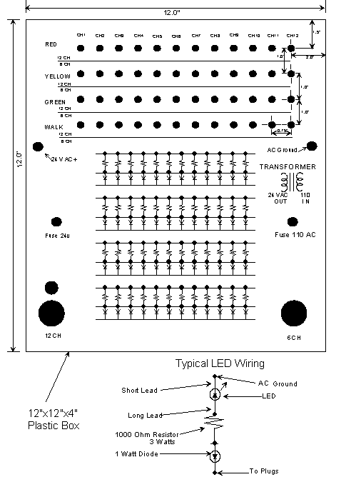

LSM6 CONNECTOR TERMINATIONS

MS-55PIN

A. AC (+) I (jumpered to AC (+) II)
B. AC (+) II Input
C. Output Relay 1 Open (relay in no-conflict state)
D. Output Relay 2 Closed (relay in non-conflict state)
E. Start-Delay Relay Open (relay in energized state)
F. Channel 6 Green
G. Channel 6 Red
H. Channel 5 Green
J. Channel 4 Green
K. Channel 4 Red
L. Channel 3 Green
M. Channel 2 Green
N. Channel 2 Red
P. Channel 1 Green
R. Red Enable
S. +24V Monitor I
T. Logic Ground
U. Chassis Ground
V. AC (-)
W. Cabinet Interlock B
X. Output Relay 1 Common
Y. Output Relay 2 Common
Z. Output Relay 2 Open (relay in no-conflict state)
a. Start-Delay Relay Common
b. Channel 6 Yellow
c. Channel 5 Yellow
d. Channel 5 Red
e. Channel 4 Yellow
f. Channel 3 Yellow
g. Channel 3 Red
h. Channel 2 Yellow
i. Channel 1 Yellow
j. Channel 1 Red
k. +24V Monitor II
m. Controller Voltage Monitor
n. +24V Monitor Inhibit
p. Cabinet Interlock A
q. Watch Dog
r. Output Relay 1 Closed (relay in no-conflict state)
s. Start Delay Relay Closed (relay in energized state)
t. Channel 6 Walk
u. Channel 5 Walk
v. Channel 4 Walk
w. Channel 3 Walk
x. Channel 2 Walk
y. Channel 1 Walk
z. Reset
AA. Red Threshold
BB. Fast Flash Enable
CC. Fast Flash Image
DD. Spare 5
EE. Status Bit A
FF. Status Bit B
GG. Status Bit C
HH. Spare 9
----. Shell Grounds

LSM12 CONNECTOR PIN TERMINATIONS

MSA-55PIN

A. AC+ I (jumpered inernally to AC+ II)
B. Output Relay 1 Open (relay in no-conflict state)
C. Output Relay 2 Closed (relay in no-conflict state)
D. Channel 12 Green
E. Channel 11 Green
F. Channel 10 Green
G. Channel 9 Green
H. Channel 8 Green
J. Channel 7 Green
K. Channel 6 Green
L. Channel 5 Green
M. Channel 4 Green
N. Channel 3 Green
P. Channel 2 Green
R. Channel 1 Green
S. +24VDC Monitor I
T. Logic Ground
U. Chassis Ground
V. AC-
W. Output Relay 1 Common
X. Output Relay 2 Common
Y. Channel 12 Yellow
Z. Channel 11 Yellow
a. Channel 10 Walk
b. Channel 10 Yellow
c. Channel 9 Yellow
d. Channel 8 Yellow
e. Channel 7 Yellow
f. Channel 6 Yellow
g. Channel 5 Yellow
h. Channel 3 Yellow
i. Channel 3 Walk
j. Channel 2 Yellow
k. Channel 1 Yellow
m. Controller Voltage Monitor
n. +24 V Monitor Inhibit
p. Output Relay 1 Closed (relay in no-conflict state)
q. Output Relay 2 Open
r. Channel 12 Walk
s. Channel 11 Walk
t. Channel 9 Walk
u. Channel 8 Walk
v. Channel 7 Walk
w. Channel 5 Walk
x. Channel 4 Yellow
y. Channel 2 Walk
z. Channel 1 Walk
AA. Spare 1
BB. Reset
CC. Cabinet Interlock A
DD. Cabinet Interlock B
EE. Channel 6 Walk
FF. Channel 4 Walk
GG. Spare 2
HH. Spare 3

MSB-26 PIN

A. AC+II Input
B. Start - Delay Relay Common
C. Start - Delay Relay Open (Relay in energized state)
D. Channel 12 Red
E. Channel 11 Red
F. Channel 9 Red
G. Channel 8 Red
H. Channel 7 Red
J. Channel 6 Red
K. Channel 5 Red
L. Channel 4 Red
M. Channel 2 Red
N. Channel 1 Red
P. Fast Flash Enable
R. +24V Monitor II
S. Watch Dog
T. Fast Flash Image
U. Start - Delay Relay closed (relay in energized state)
V. Channel 10 Red
W. Red Threshold
X. Status Bit A
Y. Status Bit B
Z. Channel 3 Red
a. Red Enable
b. Status Bit C
c. Spare 8

