Process for TR15* Contract (Signing Paid for by Applicant)

- Determine if Applicant qualifies for signs.

- Yes - District requests sign details/cost(s) from Traffic Division.

- Traffic reviews and emails District the sign details/cost(s) in Exhibit A of TR15 Contract.

- District completes contract (quantities in Ex. A & locations map in Ex. B).

- Make certain the Type of Installation, MoDOT District Number and
MoDOT Contract Administrator located in the top right corner of the first page
of the TR15 Contract is completed. (See Highlighted Areas Below)

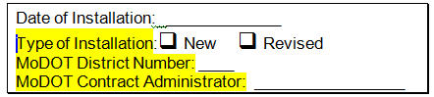

- Ensure the Authorized Person’s Title is indicated within Section (4)
of the TR15 contract. (See Highlighted Areas Below)

Note: If Authorized Person Title is not indicated, the Chief Counsel’s
Office will not approve the contract.

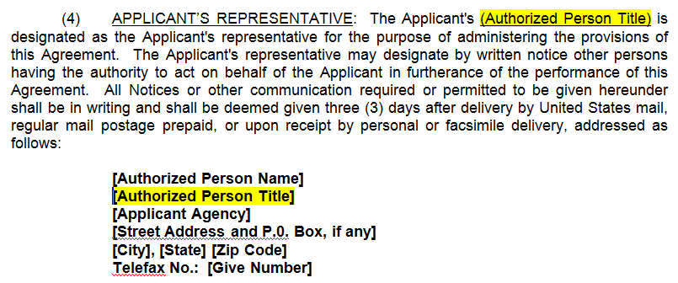

- When corresponding with Applicant, inform Applicant that he/she must indicate the contract’s name(s) for which the payment is for either on the check, check stub, or by placing a memo on the check.

- Option – If District wishes, District may have Traffic review contract before Applicant signs.

- Applicant signs completed contracts provided by District (4 color single-sided originals).
- The authorized representative named in paragraph (4) usually signs contracts.

- District sends all four contracts, the interagency invoice** & requisition to Traffic (only).
Note: The interagency invoice request (also known as the IIR form) is required for
tracking and indicates “No Payment Received” or “Payment Received”. The
IIR form is to be emailed to Traffic in spreadsheet format.

6.(a) When No Payment Received is indicated:
- After contracts are executed, Traffic emails the interagency
Invoice (also known as IIR) to Controller’s Office (CT)
for requesting payment;
- CT will email Traffic when payment is received; and
- Traffic approves requisition for signs to be manufactured.

6.(b) When Payment Received is indicated and no contract is executed:
- District sends payment to District B & B for deposit and emails
interagency invoice (also known as IIR) to CT & Traffic as
notification that payment is on its way;
- District should promptly send contracts to Traffic for execution;
- Traffic emails District & CT when contracts are executed; and
- Traffic approves requisition for the signs to be manufactured.

Note: A Requisition may be submitted prior to payment being received.

- Traffic sends contracts to Chief Counsel & Commission Secretary for execution.
- Traffic notifies the District & CT when contracts are executed by email.

- Signs are manufactured and shipped to the District for installation.
- Signs will be shipped when a full load is ready to be shipped out to the District.

- District notifies Traffic (only) the date the signs are installed.
- Traffic stamps the install date on contracts.
- Traffic will mail both the Applicant and the District a signed copy of the contract.
- Traffic will notify CT & the District of the installation date, by including the install page and the date the contracts were mailed to the District and to the Applicant.
- CT will then update the Sign Contract Report with the installation date, which is used for recording the 10-yr maintenance.

*TR-15 Contract form can be found at:
MoDOT Intranet →Division Chief Counsel→Contracts drop-down & select TR→select TR15

**Interagency Invoice Request:
Public:\drive\Traffic\Forms\Interagency Invoice Request revised date.xls
Revised 6-7-10

