Quick Reference Guide – Stockpiled Materials
MoDOT Specification 109.7.2 allows for payment to the contractor for stockpiled materials, also called “Material Allowance.” Stockpiled materials are non-perishable inspected materials for which the contractor wants payment prior to their being incorporated into the project. Refer to the specification and EPG for minimum requirements which must be met prior to payment.
The system calculates payments for stockpiled materials based on the quantity of material used per contract line item. Prior to entering data, the following must be determined:
- Which contract line item(s) should be associated to the invoiced material? It is possible to have material components included on one invoice that affect multiple contract line items.
- How much of the total invoiced material quantity should be allocated to each line item(s)?
- What material code should be associated to this material?
- What should the conversion factor be for each stockpiled material? The system will not calculate the conversion factor for you! To calculate the correct conversion factor, determine how many units of the stockpiled material item are in one unit of the contract line item.
Users with Construction Project Manager and Resident Engineer access have authority to enter, replenish, and close out stockpiled materials. Users with Construction Inspector access have authority only to view stockpiled materials.
Navigate to Contract Administration – Contract Records – Stockpiled Materials.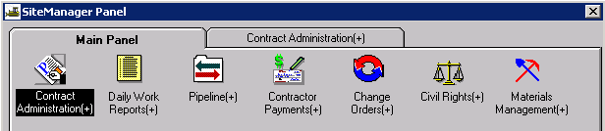
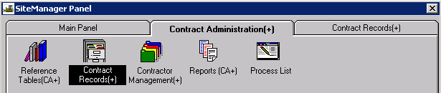
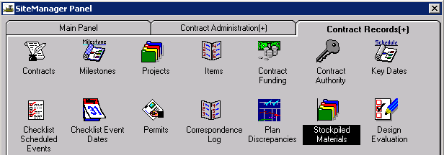

Enter New Stockpiled Material
Select Services - Choose Keys to select contract ID, project, and line number.
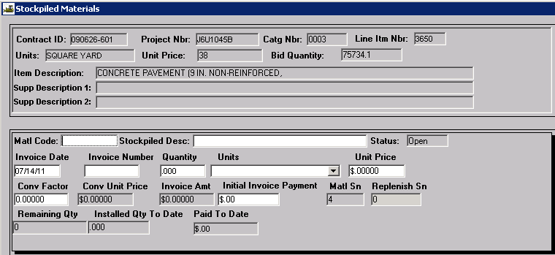
Contract line item data is displayed in the top portion of the window and stockpiled material data in the bottom portion of the window.
Matl Code: Right click to search and choose the appropriate material code from the list. If the material code is not on the list, contact the district materials person to have the material associated to the line item. Do NOT omit adding the material code for stockpiled materials. For invoices that contain multiple materials, select the material code which represents the greatest dollar value of the invoice.
Stockpiled Desc: Automatically populated by the system when the material code is selected.
Status: Automatically populated by the system with one of the following:
Open = stockpiled material has been added, but an estimate that includes this material has not been generated
Active = stockpiled material has been included on an estimate
Closed = stockpiled material has been zeroed out
Invoice Date: Automatically defaults to current date. Enter the appropriate invoice date.
Invoice Number: Enter the invoice number.
Quantity: Enter the quantity received on the invoice. For invoices that have multiple components, enter the quantity of the material which represents the greatest dollar value of the invoice.
Note: Check to see if any previous payment has been made to the line item. If so, the quantity entered cannot be greater than the remaining quantity.
Units: Select the appropriate unit of measure from the drop down.
Unit Price: Enter the invoice unit price, including tax.
To calculate this amount: (Total Invoice Amount + Tax [if applicable]) / Quantity = Unit Price.
For invoices which have multiple components, use the quantity of the material which represents the greatest dollar value of the invoice as the quantity in the calculation.
Conv Factor: The conversion factor is used during estimate generation to determine the adjustment amount for the items installed. If a conversion factor has been set up in Contract Sampling and Testing, the system will bring the conversion factor into the Stockpiled Materials window. Otherwise, the conversion factor will default to 1.0. This may be incorrect. Verify the conversion factor is correct; if not, enter the correct value. To calculate the conversion factor, determine how many units of the stockpiled material item are in one unit of the contract line item. For example, an invoice is received for bolts to be stockpiled for use on retaining walls. If each linear foot of retaining wall requires three bolts, enter a conversion factor of 3.0 for the bolts. If the units for both the line item and the stockpiled material are the same, the conversion factor will be one.
Conv Unit Price: Populated automatically and equals (Conversion Factor) x (Unit Price).
Invoice Amt: Populated automatically and equals (Quantity) x (Unit Price).
Initial Invoice Payment: Enter the amount to be paid for the stockpiled material. This will be payment on the next generated estimate.
Note: The Invoice Amt is carried to 5 decimal places and the Initial Invoice Payment is carried to only two decimal places. There have been problems when there is a difference between these two amounts (as shown below). This usually requires a manual stockpiled material adjustment of $0.01 to be made at the end of the job for each line item where this occurs.
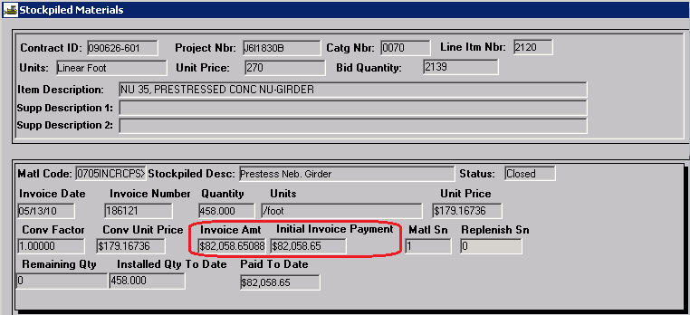
To avoid this problem, edit the Unit Price so the Invoice Amt and the Initial Invoice Payment are identical (see below). The difference in the invoice payment is minimal.
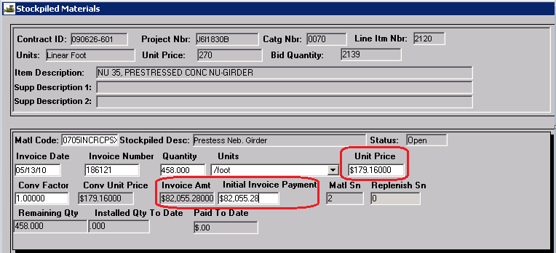
Matl Sn: The system automatically assigns a sequence number to each stockpiled material. The material sequence number will be “1” for the first instance of each material code for a given line item, and will increment by 1 for each newly created stockpile material record for the same line item.
Replenish Sn: Automatically assigned by the system. See heading “Replenish Stockpiled Material” for more information.
Remaining Qty: Automatically entered by the system, it is the difference between the original stockpiled material quantity and “Installed Qty to Date.”
Installed Qty to Date: Automatically entered by the system, it is the quantity of the stockpiled material that has been paid on DWRs
Paid to Date: The initial invoice payment, which is automatically entered by the system when the estimate is generated.
Save the stockpiled material information.
Note: The Stockpiled Materials functionality does not provide a way to indicate the location where the material is stored. Policy varies based on physical location of the material, specifically the need for legal documentation for right of access. When payment is made for stockpiled materials, the RE’s diary should note the date of payment, location(s) of the stockpiled material, whether a lease agreement was necessary, and the file location of any required lease agreement(s).

View Stockpiled Materials
From the Stockpiled Materials window, click the open icon . In the Selection window, select the contract and stockpiled material to view.

Replenish Stockpiled Materials
Once a stockpiled material has been entered in the system and another invoice is received for the same material code associated to the same line item, the Replenish Stockpile feature must be used in order for the system to correctly adjust the line item.
Navigate to the stockpiled material to be replenished using the Open function.
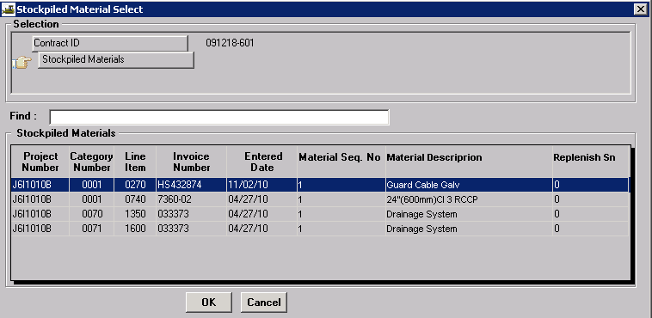

When the stockpiled material opens, select “Replenish Material” from the Services drop down menu.
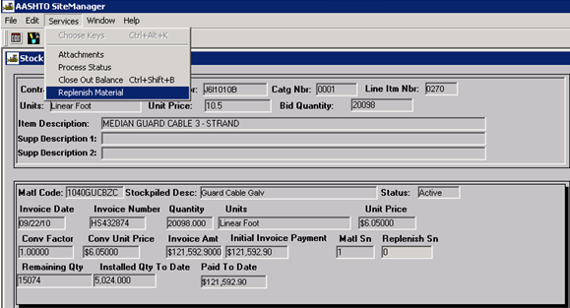
The system will copy the existing stockpile information to a new stockpiled material record which can then be modified.
Invoice Date: Edit the invoice date.
Invoice Number: Edit the invoice number.
Quantity: Edit the quantity. Remember, if any payment has been made against this line item, the quantity entered cannot be greater than the remaining quantity.
Units: The units should remain the same.
Unit Price: Edit the unit price, if necessary.
Conv Factor: The conversion factor should remain the same.
Conv Unit Price: Automatically entered by the system.
Invoice Amt: Automatically entered by the system.
Initial Invoice Payment: Enter the amount to be paid on next estimate, as detailed in “Enter New Stockpiled Material” section.
Save the record; the system will assign a new Replenish Sequence Number.

Close Out Stockpile Material Balance:
It is important to keep close watch on stockpiled materials once payment for the line item begins. Use the Cognos Stockpiled Materials report or Line Item Adjustments for Contract report to determine which invoices may need to be manually closed.
Note: If a paid invoice for the stockpiled material is not received from the contractor within 42 days of the date of the estimate on which payment for the material was made, the stockpiled material is to be manually closed and any remaining payment will be deducted from the next estimate.
Navigate to and select the stockpiled material that is to be closed using the Open function.
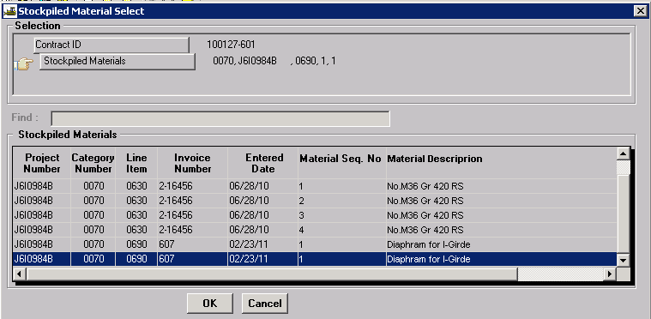
Note: If there is a pending estimate, the stockpiled material cannot be edited.
When the stockpiled material opens, select “Close Out Balance” from the Services drop down menu.
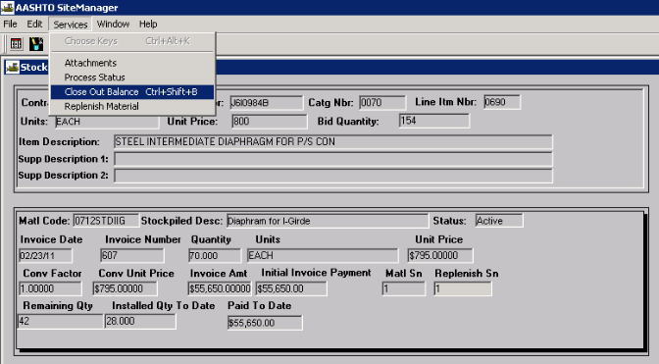
When a stockpiled material is closed out by the user, a line item adjustment (Stockpiled Material Closure) will retrieve the remaining balance that has not been recouped during usage of the stockpile when the next estimate is generated. Once a stockpiled material is closed, whether by the system or the user, all fields are protected.

Estimates & Line Item Adjustments for Stockpiled Materials
When the first estimate is generated after a stockpiled material is entered, the status of the stockpiled material becomes “Active.” No changes can be made to the record while the estimate is in “Pending” status. Once the estimate has been approved, the stockpiled material record cannot be edited except to close out the balance.
Stockpiled Materials payments are shown in the “This Estimate” column of the Estimate Summary window. To verify this payment is correct, navigate to Contractor Payments – Contract Adjustments – Line Item Adjustments and review each stockpiled material adjustment for the estimate. The Stockpiled Materials Initial Payment equals the initial payment entered by the user in the Stockpiled Materials record.

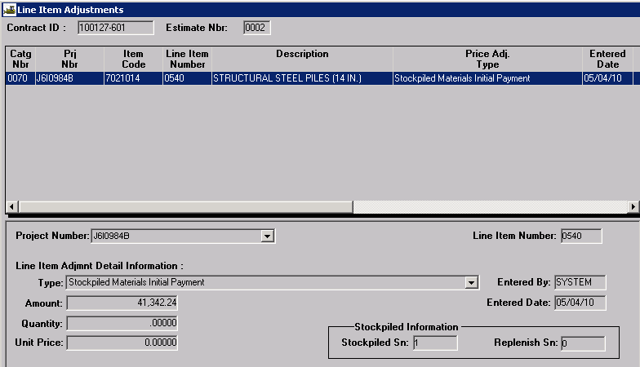

When payment begins for line items with an associated stockpiled material, the system will begin to retrieve payment by calculating a Stockpiled Materials Adjustment as shown below. 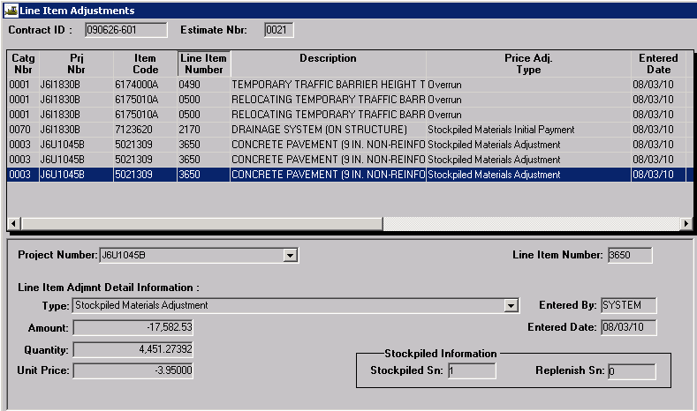
Amount: The system calculated dollar amount of the adjustment
Quantity: (Total quantity for this line item authorized on DWRs this estimate period) x (Conversion Factor for Stockpiled Material)
Unit Price: Unit price entered on the stockpiled material record

The system will automatically close a stockpiled material record when the “Remaining Quantity” reaches zero (0).
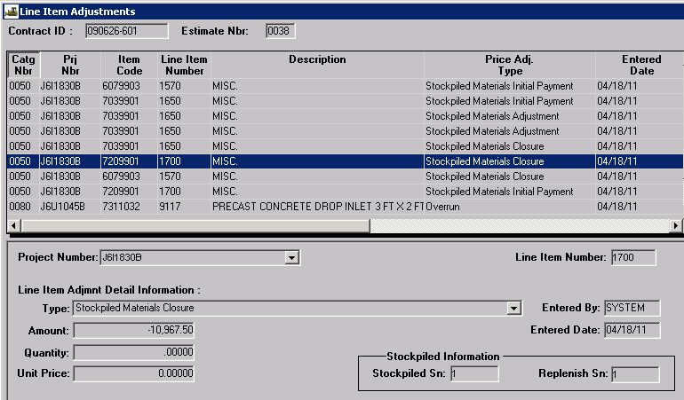
The Line Item Adjustments for Contract report in Cognos can be run for stockpiled materials only by holding the Ctrl key and clicking all three stockpiled materials adjustment types. The report can be filtered to show data for a specific estimate and/or line number.
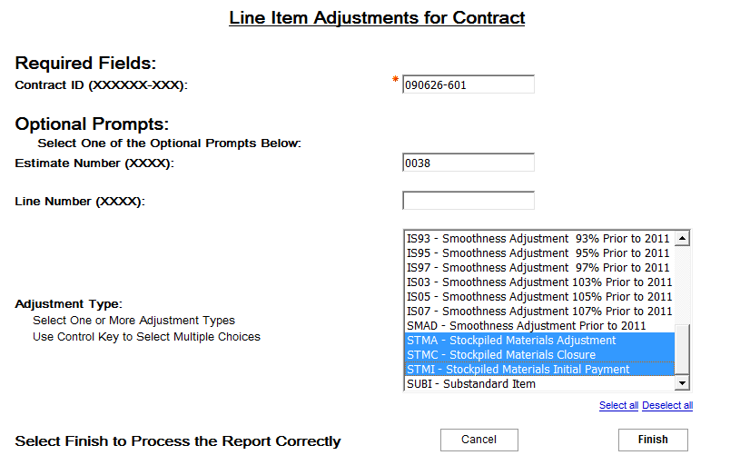
This report should be included with the estimate summary sent to the contractor.
At the end of a job, stockpiled material initial payments (STMI) plus stockpiled material adjustments (STMA) plus stockpiled material closures (STMC) for each line number should equal zero (0).
