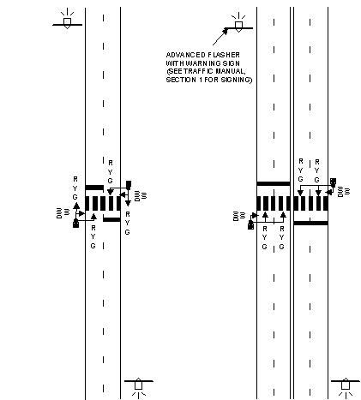

NOTE: See Standard Specifications and Standard Plans for design details.

TYPICAL MIDBLOCK SIGNAL LAYOUTS

FIGURE 5.10

