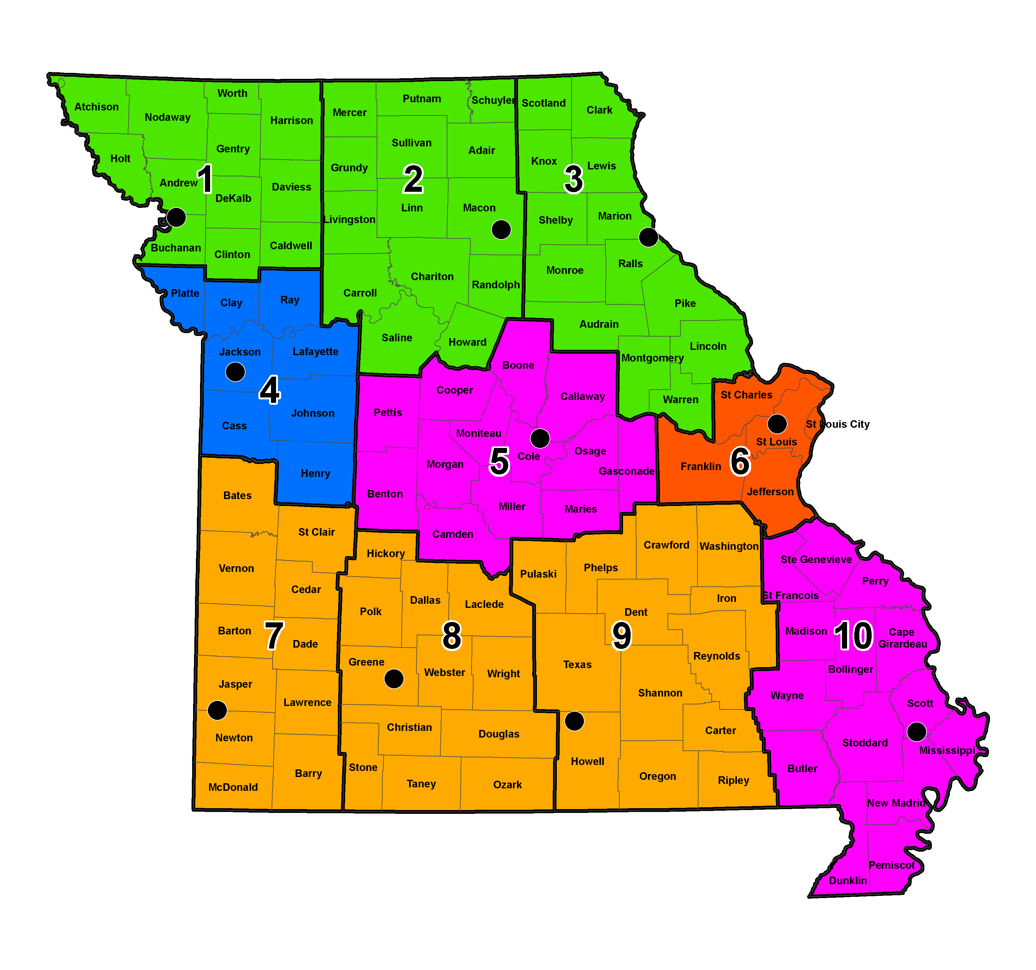

Historic Preservation Staff

Robert L. Reeder
Historic Preservation Manager
573-751-0473

Michael C. Meinkoth
Assistant Historic Preservation Manager
573-526-3593

Mailing Address:
601 W. Main St.
2nd Floor
Jefferson City, MO 65102

FAX: 573-526-1300

Email:
firstname.lastname@modot.mo.gov

District
Title Contact Phone Assignment

Senior Historic Aaron Anglen 573-526-3594
Preservation Specialist Lawrence Ayres 573-526-7836 3, 5, 7, 8, 9 & 10
(Archaeologist) Larry Grantham 573-522-5557
James Harcourt 573-526-3562 1, 2, 4 & 6
Michael Meyer 573-526-3560
Richard Rahe 573-526-7907
Travis Tesreau 573-526-3592 573-526-3590
Russell Weisman 573-526-3590

Senior Historic Karen Daniels 573-526-7346 3, 6, 8, 9 & 10
Preservation Specialist Toni Prawl 573-526-3598 1, 2, 4, 5 & 7
(Architectural Historian)

Senior Historic Randall Dawdy 573-526-3591

Preservation Specialist
(Historic Bridge Coordinator)

Senior Cartographer Sue Olson 573-526-3559 1, 2, 3, 5 & 6
Pamella Schmutzler 573-526-3561 4, 7, 8, 9 & 10

Senior Historic David Austin 573-526-3595 3, 6, 8, 9 & 10
Preservation Specialist
Intermediate Historic Jane Lee 573-522-9695 1, 2, 4, 5 & 7
Preservation Specialist
(Historian)

Intermediate Historic John (Jack) Eastman 573-526-7905
Preservation Specialist Brianne Olson 573-526-7908
(Archaeology Assistant) Terrell Martin 573-522-5556
Christopher Koenig 573-751-6752

Historic Preservation
Specialist Ronald Mayer 573-751-5184
(Archaeology Field Assistant) Timothy Porter 573-526-7906

